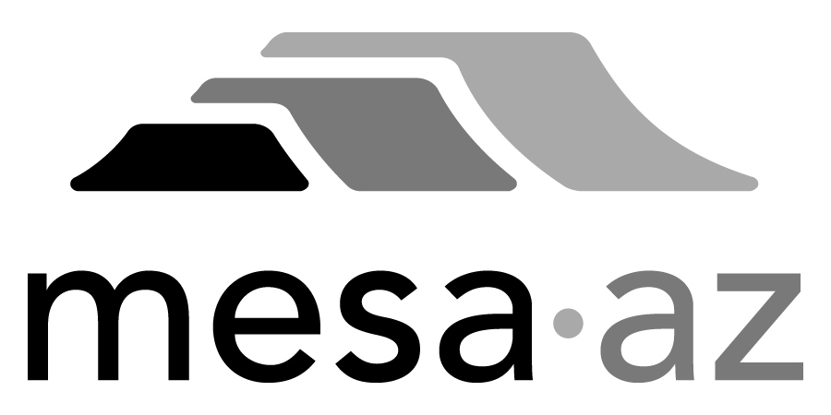 City Council Report

Date: January 27, 2025
To: City Council
Through: Michael Kennington, Deputy City Manager/Chief Financial Officer
From: Edward Quedens, Business Services Director
Kristy Garcia, Procurement Administrator
Subject: Three-Year Term Contract with Two-Year Renewal Options for Concrete Installation, Repair, and Utility Adjustment Services for the Transportation Department (Funded by Local Streets Sales Tax) (Citywide)

Recommendation

Council is requested to approve the award as recommended.

A committee representing the Transportation and Business Services Departments and Procurement Services evaluated responses. The evaluation committee recommends awarding the contract to the highest scored proposal from Lincoln Constructors, Inc. at $7,265,220 annually, with an annual increase allowance of up to 5% or the adjusted Consumer Price Index.

Background / Discussion

This contract will provide concrete installation and repair services to include concrete removal, installation, repair, and other related services, and utility adjustment services. The contractor will provide all materials, labor, and equipment required to perform concrete installation and repair services under this contract.

Concrete repair and installation services will include minor concrete work such as sidewalks, valley gutters, ADA ramps, and storm drain assets, along with adjustments to gas and water valves, survey monuments, sewer cleanouts, and manholes associated with utility cut repairs, failed utility frames, and related services. The contractor must supply all concrete materials, while the City will provide manhole and valve hardware, frames, and lids.

City staff issued a Request for Proposal (RFP) to all registered Concrete Installation, Repair, and Utility Adjustment Service providers. Four (4) proposal responses were received. All proposals met the minimum qualifications and were evaluated and scored in accordance with the City’s established policies and procedures and relative to the scoring criteria in the solicitation. Based on the evaluation results, the committee recommends awarding the contract to the highest-scoring respondent.

Purchase Information

Action: Award
Procurement Type: Request for Proposals
Contract Number: 2025019
Local Consideration: Policy did not apply to this procurement method
Protests Received: None
Initial Contract Term: Three (3) years
Possible Renewals: Up to a maximum of two (2) years subject to Administrative review and approval
Funding Source: Transportation operating budget through Local Street Sales Tax

Proposal Responses

Hunter Contracting, Co. – Gilbert, AZ
Lincoln Constructors, Inc. – Phoenix, AZ (Recommended)
Nesbitt Contracting, Co., Inc. – Tempe, AZ
Talis Construction, Corp. – Mesa, AZ

Proposal Scoring Results

Respondent | Total Points Possible / 1,000
Hunter Contracting, Co. | 783.00
Lincoln Constructors, Inc. (Recommended) | 939.00
Nesbitt Contracting, Co., Inc. | 796.00
Talis Construction, Corp. | 874.00

