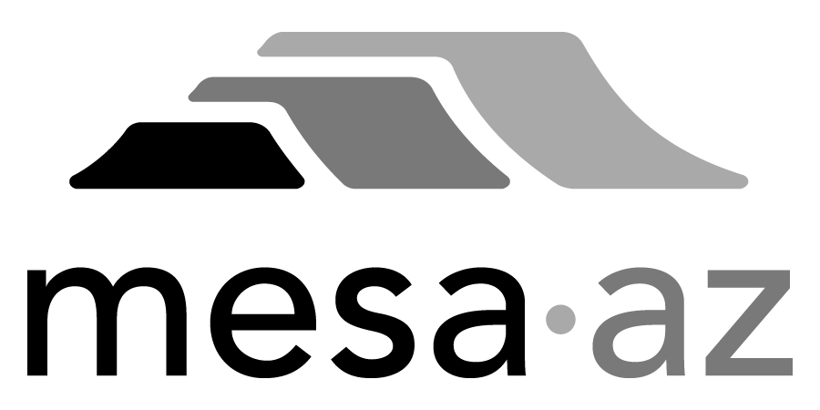 City Council Report

Date: January 27, 2025
To: City Council
Through: Michael Kennington, Deputy City Manager/Chief Financial Officer
From: Edward Quedens, Business Services Director
Kristy Garcia, Procurement Administrator
Subject: One-Year Term Contract for Dynamo Playground Equipment Repair and Replacement Parts for the Parks, Recreation and Community Facilities Department (Sole Source) (Citywide)

Recommendation

Council is requested to approve the award as recommended.

The Parks, Recreation and Community Facilities Department and Procurement Services recommend awarding the contract to the sole source vendor, Dynamo Industries at $300,000, based on estimated requirements.

Background / Discussion

The City has seven (7) parks that have playground equipment manufactured by Dynamo Industries. The Dynamo playground park equipment installed at Eastmark Great Park and Riverview Park is proprietary and was custom-designed for these parks. This contract will provide maintenance, repairs, and add-on equipment for all the City’s Dynamo playground equipment.

Dynamo Industries is the sole source for repair and replacement parts for all Dynamo playground equipment.

Purchase Information

Action: Award
Procurement Type: Sole Source
Contract Number: 2025121
Local Consideration: Policy did not apply to this procurement method
Protests Received: None
Initial Contract Term: One (1) year
Possible Renewals: None
Funding Source: Parks, Recreation and Community Facilities Department operating budget through the Environmental Compliance Fee (Basin Maintenance), General Fund budget (Parks Maintenance, Eastmark Park, Riverview Park, and Sports Complex Maintenance) and Commercial Facilities fund (Hohokam and Fitch Park)

