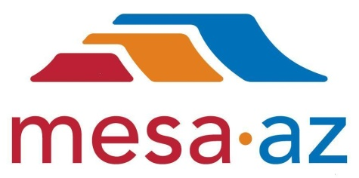 | City of Mesa  Energy Resources Department  P.O. Box 1466 Phone: 480.644.4444  Mesa, AZ 85211-1466 Fax: 480.644.3336  E-mail: EnergyResources.info@mesaaz.gov

2024 Integrated Resource Plan

City of Mesa Energy Resources Department
Maricopa County
State of Arizona

Contents
City of Mesa Energy Resources Department 1
Contents 2
List of Acronyms 4
Section 1.0 – Background – The City of Mesa Electric Utility 5
1.1 – Mesa City Council 7
1.2 – IRP Responsibility 8
Section 2.0 – Background – The Regional Electric Market 8
Section 3.0 City of Mesa – Current Electric Supply Resources 13
3.1 – Federal Hydropower Resources 13
3.2 – Utility-Scale Renewable Energy Projects 14
3.3 – Locally Generated Resources 16
3.4 – Conventional Energy Resources 18
3.5 - Electric Transmission Resources 20
Section 4.0 – The IRP Process & Goals 22
Section 5.0 Customer Requirements and Resource Needs Forecast 24
5.1 – Overall System Load Forecast 24
5.2 – Customer Profile 25
Section 6.0 Resource Options 29
6.1 – Market-Based Contractual Conventional Resources 30
6.2 – Utility Scale Renewable Resources 31
6.2.1 Market Purchased Solar Energy: 32
6.2.2 Market Purchased Wind Energy: 32
6.2.2 Other Market Purchased Renewable Resources: 33
6.3 – Local Conventional Resources 34
6.4 – Local Renewable Resources 35
6.5 – Customer Resources 36
6.5.1 Customer Solar Resources 36
6.5.2 Customer Battery Resources 37
6.5.2 Virtual Power Plant Resources 37
6.5.3 Demand Side Management Resources 38
Section 7.0 Public Input 39
Section 8.0 – Considerations in Selecting a Resource Portfolio 43
8.1 – Alignment with Customer Sourced IRP Feedback 43
8.2 – Alignment with City Management and Council Goals 44
8.3 – Alignment with Department Goals 45
Section 9.0 – Proposed IRP Scenarios 45
9.1 – Preferred Scenario: Least Cost Mix of Conventional & Renewables Portfolio 48
9.2 – Alternative Scenario 1: Conventional Resources Portfolio 51
9.3 – Alternative Scenario 2: Solar/Renewable Focused Portfolio 53
Section 10.0 – Recommended Action Plan 54
Appendix A: Solar Energy Effect “Duck Curve” 1
Appendix B: First Customer Survey Full Results 1
Appendix C: Western Area Power Administration IRP Requirements 1

List of Acronyms
ACC – Arizona Corporation Commission
AEPCO – Arizona Electric Power Cooperative
AMI – Advanced Metering Infrastructure
APS – Arizona Public Service
BA – Balancing Authority
CAISO – California Independent System Operator
CIS – Customer Information System
CFL – Compact Fluorescent Lightbulb
COD – Commercial Operation Date
CRSP – Colorado River Storage Project
DC – Direct Current
DSM – Demand Side Management
EEI – Edison Electric Institute
ESA – Electric Service Area
EV – Electric Vehicle
GW – Gigawatt (1,000 MW, 1,000,000 kW, or 1,000,000,000 Watts)
IRA – Inflation Reduction Act
IRP – Integrated Resource Plan
ITC – Investment Tax Credit
kV – kilovolt (1,000 volts)
kW – kilowatt (1,000 Watts)
LED – Light Emitting Diode
MCAP – Mesa Climate Action Plan
MW – Megawatt (1,000 kW or 1,000,000 Watts)
NGS – Navajo Generating Station
NITS – Network Integrated Transmission Service
PPA – Power Purchase Agreement
P-DP – Parker-Davis Project
PTC – Production Tax Credit
PV – Photovoltaic
REC – Renewable Energy Credit
REST – Renewable Energy Standard and Tariff
RMS – WAPA’s Resource Management Services group
SEER – Seasonal Energy Efficiency Ratio
SPPA – Southwest Public Power Agency
SRP – Salt River Project
TEP – Tucson Electric Power
TOU – Time-of-Use (rate)
UV – Ultraviolet
WALC – WAPA’s Western Area Lower Colorado balancing authority
WAPA – Department of Energy Western Area Power Administration
WECC – Western Electricity Coordinating Council
WSPP – Western Systems Power Pool

Section 1.0 – Background – The City of Mesa Electric Utility
The City of Mesa is a full-service Arizona municipality initially settled by pioneers in the 1870’s and incorporated in 1883. Mesa is the State of Arizona’s third largest city by population and has operated its own electric utility since 1917. The current electric service area (ESA) was established by the Arizona Supreme Court on September 15, 1954 and approximates the incorporated city limits as they were at that time and additional service territory was incorporated via eminent domain in 1962.
Mesa has had a storied history of resources that has always been integrated with the resource directions taken by other entities in the state. Mesa has participated in federal hydropower resources including the Parker-Davis Project, the Colorado River Storage Project and the Boulder Canyon Project from time to time. Mesa has acted alongside similarly situated utilities such as Electrical District Number 2 in Casa Grande through the Arizona Power Pooling Association. Mesa has participated in dispatchable, conventional resources alongside other utilities such as the Apache Generating Station through the Arizona Electric Power Cooperative. Mesa has also had a history of owning and operating generating assets from time to time. Mesa has always innovated and adapted to put in place the most advantageous resources for the time to provide reliable and affordable power supply for its customers.
Mesa’s ESA is approximately 5.5 square miles and encompasses the heart of the city, including the original town site. Over the past two decades, Mesa’s customer base has shifted dramatically. Prior to the great recession of 2007 and 2008, Mesa’s system had grown to 16,462 customers and experienced a peak demand of 93.8 MW (96.2 MW weather adjusted). During the recession, high vacancy rates caused Mesa’s customer count to steadily drop to just over 15,000 customers, seeing its lowest by January of 2010. Beyond that time, Mesa has seen a resurgence in interest in development in the downtown area due to a persistent effort by City leaders and staff to revitalize the area. As of November, 2024, service within this area was provided to 18,179 customers of whom 15,402 were residential customers, 2,551 were commercial and the remaining 226 were the City itself or other governmental entities. The majority of this growth in customer numbers is the result of redevelopment of vacant parcels downtown into mid-rise (2-5 story) multi-family housing. Developments such as the Grove on Main, ECOMesa, Melody on Main, and 2nd Avenue Commons have driven growth in the downtown area, with commercial development following close behind. More of these multi-family developments are already in the planning stages or under construction and so Mesa must intelligently plan to meet these additional demands with affordable and reliable electric supplies.
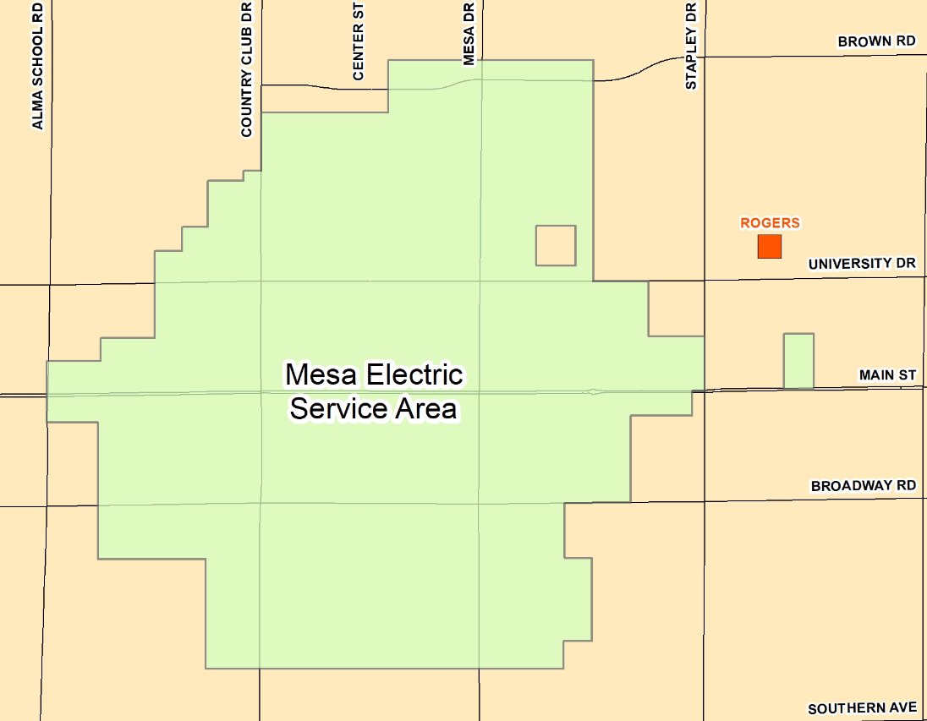
Figure 1) City of Mesa Electric Service Area (ESA)
Another substantial change since Mesa’s last IRP is the publication of Mesa’s Climate Action Plan (MCAP) in June of 2022. The MCAP has aspirational goals that will guide the direction of the electric utility. The MCAP’s goal related to greenhouse gas emissions from City Operations is a reduction by 50% by 2030; the goal for 2050 is full carbon neutrality; and the goal for renewable energy by 2050 is 100% in addition to other goals:
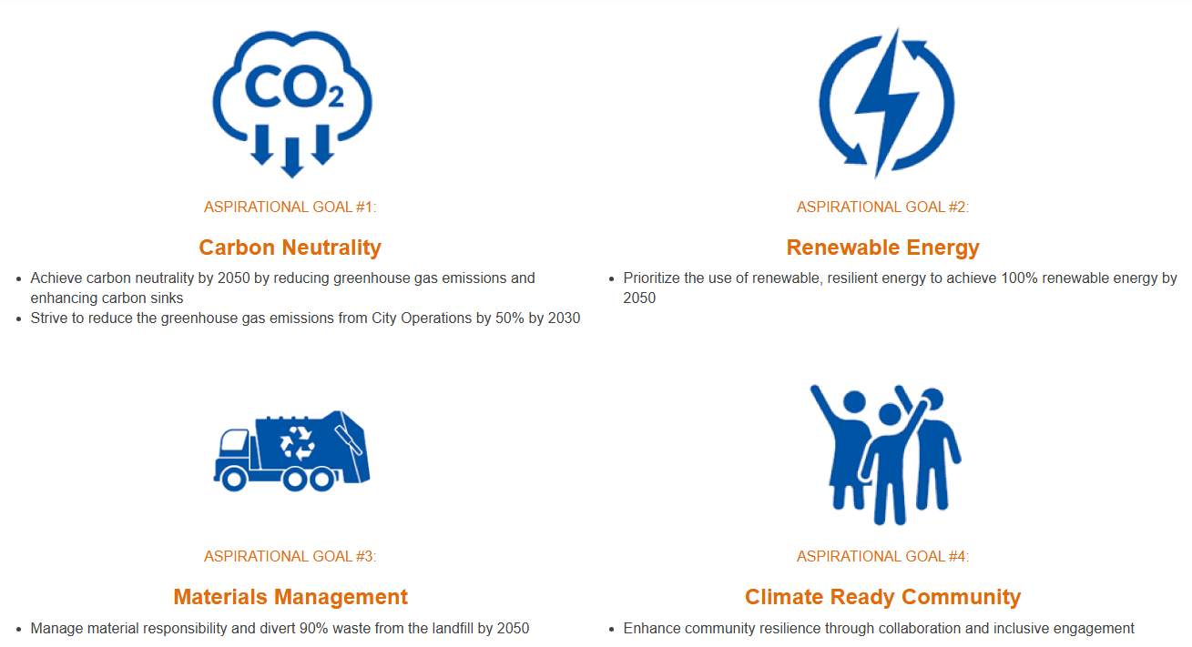
Figure 2) High level goals of Mesa's Climate Action Plan
As a result of the MCAP, Mesa must now evaluate its electric supply resource choices within the context of achieving these goals.

1.1 – Mesa City Council
The City’s electric rates are established by ordinance and adopted by the City Council. All resource acquisitions must be authorized by Mesa’s City Council. Mesa’s City Council is comprised of six council members and the mayor. Each councilmember is elected from one of six voting districts in Mesa, with the mayor being elected at large. The current City Council members are listed below:

City Council
Mark Freeman – Mayor
Rich Adams – Vice Mayor, Councilmember, District 1
Julie Spilsbury – Councilmember, District 2
Francisco Heredia – Councilmember, District 3
Jennifer Duff – Councilmember, District 4
Alicia Goforth – Councilmember, District 5
Scott Somers–Councilmember, District 6

1.2 – IRP Responsibility
Mesa’s Energy Resources Department is responsible for planning and acquiring the electric power resources required to meet the electrical service needs of its customers. Under the direction of the Energy Resources Department Director, the Energy Resources Department is specifically charged with this task. Additionally, the Energy Resources Department is charged with monitoring and updating Mesa’s IRP. Mesa personnel responsible for the IRP are listed below.

Scott Bouchie  Energy Resources and Sustainability Director  P.O. Box 1466  Mesa, AZ 85211-1466  Ph: 480-644-4366 | Anthony Cadorin  Energy Resources Program Manager  P.O. Box 1466  Mesa, AZ 85211-1466  Ph: 480-644-6898 | Deb Ferraro  Energy Resources Coordinator - Electric  P.O. Box 1466  Mesa, AZ 85211-1466  Ph: 480-644-6970 | Giao Tran  Energy Resources Coordinator – Natural Gas  P.O. Box 1466  Mesa, AZ 85211-1466  Ph: 480-644-6429

Section 2.0 – Background – The Regional Electric Market
The City of Mesa’s electric utility is located in the “Western Interconnect” grid of North America which spans from British Columbia and Alberta, Canada all the way south to Baja California, Mexico and includes parts of New Mexico, Colorado, Wyoming, Montana, and South Dakota. This is to say that the entirety of that geographical region is highly interconnected, however, it doesn’t act unilaterally. Within the region, it is subdivided into 38 different sub-grids known as “Balancing Authorities”. Each Balancing Authority acts as a semi-contained grid that balances the loads (i.e. customer-serving distribution utilities) and resources (i.e. power generating plants) on a real time basis to maintain adequate voltage and frequency and avoid outages or other issues. Mesa’s load sits within the Western Area Lower Colorado (WALC) balancing authority which is controlled by the Western Area Power Administration (WAPA) in Phoenix, Arizona. WAPA aggregates loads and resources for all the entities within the WALC, monitors the grid’s frequency and voltage and then will bring online more resources or back off on certain resources to ensure that the grid is properly balanced.
These transactions used to be performed by WAPA and then reconciled based on WAPA’s best efforts to determine the cause of each resource shortage or overage. However, in April of 2021, WAPA brought the WALC into the California Independent System Operator (CAISO) Energy Imbalance Market (EIM) to be able to settle individual utilities’ imbalances real time; increase the operating efficiency of the grid; and to (ideally) save participating utilities money in the process. The EIM allows utilities that are “long” resources to trade that position with utilities that are “short” resources in near real time, which reduces inefficiencies in the system and pairs utilities with the most economical resources possible.
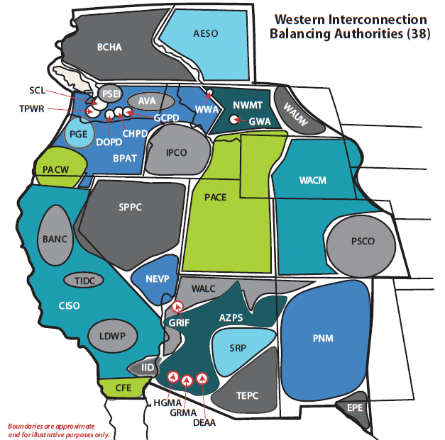
Figure 3) Approximate boundaries of balancing authorities within the WECC

Through the five years that have passed since Mesa’s last IRP, the western energy market underwent a fundamental shift that substantially undermined Mesa’s competitive advantage with regards to supply costs.
The Southwest’s population has continued to grow at the highest rates in the country, which has kept electric demand growing despite gains in energy efficiency. Electric vehicle sales have increased 385% since 2019 and are projected to continue to see growth for years to come. Lastly, data centers have been a rapid source of growth in electric demand for the southwest. Though the latter has not occurred directly within Mesa’s service territory, these factors on a regional basis have combined to drive continued record setting peak demand numbers.
Simultaneously, the supply of electricity in the region has also undergone a monumental shift. The large utilities in the southwest have unanimously moved to shutter the region’s large coal fired powerplants. The closure of the 2,250 MW Navajo Generation Station (NGS) in 2019 served as a pivot point for the region. Although Arizona Public Service (APS) had already retired Unit 2 of the Cholla Generation Station in 2015 and Unit 2 of the San Juan Generating Station in April 2016 for a combined total of ~460 MW of capacity, the retirement of NGS, seen as one of the largest power plants of the region, was a far greater reduction in the regional capacity. Of the 2,250 MW total from NGS, Arizona entities (namely APS, SRP, and Tucson Electric Power) received 945 MW of that capacity.

Figure 4) The total coal fired powerplant capacity for SRP, APS, Tucson Electric Power (TEP) and AEPCO by year including a projection into the future with announced, planned retirements.
Looking forward, the region will see continued gradual retirements of capacity until 2031 and 2032 when all five units of the Four Corners Steam Plant and the two units of the Coronado Generating Station will be retired for a total of over 3 GW of Arizona entity capacity coming offline (approximately 600 MW more capacity will be retired in those years which is off-taken by other entities). This time period will prove particularly difficult for Mesa if sufficient resources aren’t already secured.
During this timeframe, far fewer conventional resources were successfully commissioned and brought online. APS commissioned its Ocotillo Modernization project in 2019 which retired ~220 MW of antiquated steam turbines and installed 504 MW of new LMS100 natural gas fired combustion turbines. Tucson Electric Power (TEP) commissioned its new natural gas powered Wartsila rotating internal combustion engine based ~180 MW power plant at the Sundt Generating Station in 2020. SRP has been progressively bringing online natural gas combustion turbines at its existing power plants with two units installed at the Agua Fria Generating Station (2022, 100 MW), two units at Desert Basin Generating Station (2022, 100 MW), and two units at Copper Crossing Generating Station (2024, 100 MW). Though these incremental, modern, fast acting natural gas resources will be extremely valuable to the operation of the local grid, their size and scope do not rival the magnitude of the loss of coal capacity.
But perhaps most remarkable has been the construction of battery-based energy storage resources throughout the southwest during this period. Following the rolling blackouts in California in summer of 2020, battery construction in the region has been aggressive and effective. In 2020, between Arizona and the four surrounding states, battery capacity has grown from 631 MW in 2020 to over 14,000 MW by 2024 with many more resources to come online in the near future.

Figure 5) The total combined capacity of battery energy storage resources located in Arizona, Nevada, California, New Mexico and Utah by year (2024 is CYTD through September). Source: EIA 860M - September 2024
This massive deployment of battery resources (combined with solar and wind resources) has calmed energy markets since 2020 and brought wholesale energy pricing down significantly.
Another regional phenomena that must be considered is the progressive degradation of air quality within Maricopa County. As air quality continues to degrade, the regulations become more stringent and obtaining air permits for power generation becomes more challenging, if possible at all. In February of 2025, Arizona is likely going to be downgraded from moderate non-attainment for ozone to serious non-attainment for ozone in Maricopa County. This means the amount of VOCs and NOX that can be emitted through an air permit will be reduced by half. Since NOX is one of the main pollutants from fuel combustion, prime generator engines used for power generation will be limited in runtime hours to meet the lower pollution parameters.
Looking forward, Mesa has analyzed all available market-derived supply options (including Mesa-owned generation options), demand-side options and customer-owned generation options. Mesa’s resource needs for the IRP timeframe are identified and plans to acquire the preferred resources are presented. This IRP will serve as a guide for Mesa to continue meeting current and future load requirements in a safe, reliable, economical, sustainable and customer-responsive manner. Additionally, this Plan also addresses a number of other issues such as demand-side management (DSM) strategies and how to address requests for interconnection of customer-owned distributed generation.

Section 3.0 City of Mesa – Current Electric Supply Resources
Mesa has put in significant efforts across the past decade to diversify its electric supply resource portfolio. Aside from Mesa’s long-time participation in federal hydropower projects, Mesa has leaned heavily on wholesale energy markets to provide the vast majority of its electric supply. The results of those efforts to diversify are now starting to come to fruition as Mesa brings online other resources to complement its historic portfolio. This portfolio is currently split into four major categories:

3.1 – Federal Hydropower Resources
Mesa is currently the recipient of two hydroelectric generation resources; the Parker-Davis Project and the Colorado River Storage Project. Combined, on an energy basis, these two resources have contributed approximately 20% of Mesa’s annual energy supply requirements.
Parker Davis Project
The Parker-Davis Project (P-DP) consists of the Parker and Davis Dams which retain the Lake Havasu and Lake Mohave reservoirs, respectively, on the Colorado River. The Parker Dam has a nameplate capacity of 120 MW and the Davis Dam has a nameplate capacity of 240 MW. Mesa has received power from the P-DP since at least the mid 1960’s. Initially a recipient of 13.45 MW, at some point during the 1960’s Mesa gave 3 MW back which was allocated to the irrigation districts leaving Mesa with 10.45 MW beginning at least as early as 1965. The resource was renewed in 1976 through 1988 and then renewed once more in 1988. In 2008 during the most recent remarketing, all of the contractors sacrificed capacity to create a resource pool for new applicants and Mesa’s allocation was reduced to 10.379 MW of summer capacity where it remains currently. Western is currently undergoing the process to remarket the P-DP resource in anticipation of the expiration of the current contracts in 2028.
Colorado River Storage Project
The Colorado River Storage Project (CRSP) is the combination of Glen Canyon Dam, Navajo Dam, Flaming Gorge Dam and the system of dams along the Gunnison River (Blue Mesa, Crystal and Morrow Point dams). The Glen Canyon Dam, which holds back Lake Powell on the border of Arizona and Utah, is by far the largest contributor of power to the CRSP (accounting for almost 75% of the generating capacity). CRSP was put into service in the mid-1960’s. Mesa first began receiving power from CRSP in 1989 with the receipt of 4.637 MW. When the resource was remarketed in 2004, similar to the P-DP Remarketing four years later, all of the contractors sacrificed some capacity to create a resource pool for new applicants and Mesa’s allocation was reduced to 4.312 MW of summer capacity where it remains currently. Mesa extended its allocation of CRSP hydroelectric power beginning in October of 2024 and extending through 2057 with the same capacity as its 2004 allocation.

3.2 – Utility-Scale Renewable Energy Projects
Mesa has endeavored since its last IRP to create opportunities for participation in large-scale renewable energy projects. To that end, Mesa has successfully entered its first large-scale renewable energy project with the Salt River Project Agricultural Improvement and Power District (SRP) and has received authorization from its city council to participate in another large-scale renewable energy project with the Arizona Electric Power Cooperative (AEPCO).
SRP Renewable Energy Project
The SRP Renewable Energy Project provides for up to 16 MW of firm Western Systems Power Pool (WSPP) Schedule C capacity and energy in the summer that follows a solar power shape. In addition, Mesa will be provided with Renewable Energy Credits to cover 100% of the energy that is delivered by SRP. In this sense, it is not a true, resource specific renewable energy project, but is more akin to the typical power products that Mesa purchases from time to time on the wholesale energy market. Importantly, the resource is “firm”, meaning that any failure to deliver the power (outside of an event of force majeure) will result in SRP paying Mesa any positive difference for the energy that Mesa has to buy to cover the loss. This power will be delivered to the Pinnacle Peak 230 kV substation whereby Mesa will use its transmission rights with WAPA to deliver the power back to Rogers. Deliveries will begin on January 1, 2025 for a term of ten years.
AEPCO Pinal Solar Project
The AEPCO Pinal Solar Project is an exciting opportunity where AEPCO has successfully secured a federal grant to substantially reduce the cost of a solar project in the state. Importantly, AEPCO will be allowing smaller utilities like Mesa to participate together to achieve economies of scale that wouldn’t be available if the utilities tried to do similar projects on an individual basis. The project is being developed by an industry-leading developer of utility-scale renewable energy projects. The project is currently being designed with 400 MW of single axis tracking solar photovoltaic capacity, of which Mesa has subscribed to 25 MW. There will also be ~400 MW of battery energy storage capacity, of which Mesa has subscribed to 20 MW. The project is currently in the preliminary negotiation phase where participants will be funding the development phase of the project’s design and legal negotiations. The project is envisioned to begin deliveries in June 2027 to the ED5 substation near Picacho Peak whereby Mesa will use its transmission rights with WAPA to deliver the power back to Rogers. The term of the agreement is currently envisioned as 20 years. With certain limitations, Mesa was authorized in October 2024 by the city council to begin negotiations for agreements to participate in the project.

3.3 – Locally Generated Resources
City of Mesa – Solon – Downtown Solar 1
Mesa successfully developed its first utility interconnected solar projects through power purchase agreements (PPAs) with developer Solon Incorporated. The four projects were added to Mesa’s power supply portfolio and have been successfully owned and operated by subsidiary companies of Onyx Renewable Partners, LP, providing renewable energy and shade to the downtown Mesa Plaza area. These projects were executed via 25-year power purchase agreements and will be operated and maintained by the Onyx companies for their lifetime unless Mesa elects to purchase them after their sixth year of operation:
Table 1) Summary of the Downtown Solar 1 Projects
Project | Project Size (kW-DC) | Commercial Operation Date:
Arizona State University Creative Futures Laboratory Rooftop Solar | 391.05 | 10/5/2022
City of Mesa Ice Rink Building | 40.95 | 3/7/2022
Mesa City Plaza Parking Lot | 149.76 | 12/22/2022
55 N Center St Municipal Building Parking Lot | 224.64 | 12/22/2022

City of Mesa – Solon – Downtown Solar 2
Mesa is working to develop its second utility interconnected solar projects through PPAs with developer Solon Incorporated. These next four projects will also provide renewable energy and shade to the downtown area. These projects were executed via 25-year PPAs and will be similarly operated and maintained by the Onyx companies for their lifetime unless Mesa elects to purchase them after their sixth year of operation. Completion of all the projects is tentatively projected for Q2 of 2025:
Table 2) Summary of the Downtown Solar 2 Projects
Project | Estimated Project Size (kW-DC) | Estimated Commercial Operation Date:
City of Mesa Solid Waste Building and Electric Meter Shop | 556.325 | 7/2025
CK Luster Building | 712.215 | 5/2025
Transportation Building | 1,019.83 | 6/2025
City of Mesa Main Library | 555.135 | 3/2025

City of Mesa Customer Solar Program
Beginning in 2012, Mesa began providing incentives to assist customers with installation of solar on their homes and businesses. Since then, Mesa has successfully assisted customers in installing 211 solar photovoltaic systems for just over 2.33 MW-DC of interconnected solar capacity. Mesa continues to be one of the few utilities in the state of Arizona with a true net metering program. This program, however, has limits where residential systems are limited to 5 kW without battery energy storage and 10 kW with battery energy storage. Commercial systems do not have limits; however, net metering is only offered to commercial systems up to 50 kW.
City of Mesa Public Safety Campus Microgrid
The City of Mesa is actively in the design phase of a 3 MW natural gas-fired generator that will be located at the public safety campus in downtown Mesa. This generator will serve two purposes: it will serve as a generation resource for the utility during “normal” operating times and it will also serve as a full-power backup resource for the campus if there is ever an outage on the grid. The public safety campus encompasses the Police Department Administration Building, the Central Police Division substation, Police Department Forensic Services, the Mesa Center for Higher Education and the Police Department Evidence Building which are all critical buildings for the continuity of operations of the Police Department. The project will install a series of sensors, switches and controls so that if power is lost to the campus due to a disruption in the grid, the public safety campus will isolate itself and bring the generators up to speed to carry the load of the buildings on the campus as if there were no outage at all.
During “normal” operating times, the generators will be run whenever it is less expensive to run them than to purchase power on the wholesale electricity market, saving customers money (commonly referred to as “economic dispatch”).
Due to increasing capital costs of the project, Mesa is re-evaluating the project’s economics and applying for grant assistance to offset up-front costs.
City of Mesa Electric Utility Smart Peaks Program
The City of Mesa’s Electric Utility Smart Peaks Program (or “Smart Peaks” for short) was launched in 2023 as a response to a highly volatile wholesale energy market seen in summers of 2020, 2021 and 2022. This program allows customers to enroll their smart thermostats (“bring your own thermostat”) which allows Mesa to call on those thermostats during times when market pricing is very high to adjust the temperature upwards and reduce peak demand on the system. Since the program’s inception, Mesa has enrolled 96 participants which are estimated to be able to save 500 kW on days with high demand.

3.4 – Conventional Energy Resources
EEI/WSPP Schedule C Energy Purchases
Beginning in approximately 2001, Mesa began purchasing power on the wholesale electricity market using industry standard master agreements such as the Edison Electric Institute’s Master Power Purchase and Sale Agreement (EEI) and the WSPP Agreement. Mesa puts in place an “enabling agreement” with an electric supplier that sets out terms for all of the transactions in the future between Mesa and the supplier. Mesa is currently enabled with seven entities who all actively trade power in the southwest, which maximizes competition for Mesa’s business and helps minimize costs. Mesa is actively working on becoming enabled with additional suppliers to increase competition even more. Power purchased on the wholesale market is traded in “blocks” which are denoted by the number of days of the week that the power is delivered and the number of hours in the day that the power is delivered. So a ”7x24” product delivers power seven days per week and 24 hours per day and a “6x16” product delivers power six days per week (Monday – Saturday typically) and 16 hours per day (from 6 AM to 10 PM typically). Mesa is then able to stack these “blocks” to resemble the demand of the utility. Throughout the years Mesa has had a variety of different power contracts that were procured in this manner, but currently, Mesa’s supply is as follows:
Table 3) Current electric supply contracts
Counterparty | Capacity | Sched. | Months | Delivery Point | Start Date | End Date
Constellation | 10 MW | 7x24 | All | West Wing 500 | Current | 12/2025
Constellation | 15 MW | 7x24 | All | Mead 230 | Current | 4/2025
Constellation | 15 MW | 7x24 | All | Mead 230 | 5/2025 | 4/2028
Constellation | 5 MW | 7x16 | July-Aug | West Wing 500 | Current | 8/2025
Citi | 10 MW | 7x16 | July-Aug | Pinnacle Peak 230 | 7/2025 | 8/2027
BP | 15 MW | 6x16 | June-Sept | West Wing 500 | 6/2025 | 9/2026

Resource Management Services Group
Mesa participates in WAPA’s Resource Management Services (RMS) group along with Electrical District 2, the Town of Fredonia and Aha Macav Power Services. Through participation in the Western Area Power Administration’s (WAPA) Resource Management Services (RMS) group, Mesa is provided with the following services:
- Mesa is able to gain access to the regional electric energy markets and acquire short-term resources to meet the customers’ requirements that are not met through the acquisition of long-term agreements.
- WAPA dispatches and schedules the aggregated resources to minimize the costs to the members. This service is provided on a real-time basis to make sure that Mesa has enough resources in all hours of the day.
- Whenever one entity in the group has extra resources, other participants in the group can utilize those resources rather than having to purchase more resource on the wholesale energy market.
- RMS provides analyses on Mesa’s resource portfolio choices and transmission choices.

3.5 - Electric Transmission Resources
Mesa’s 69 kV transmission system is interconnected to the bulk electric system at the Rogers Substation which is co-owned by SRP and Mesa. Rogers serves as the junction of two WAPA 230 kV lines that extend from the Pinnacle Peak 230 kV Substation to Rogers and one WAPA 230 kV line that extends from the Coolidge 230 kV substation. Additionally, SRP is interconnected at the Rogers Substation to lines from the Thunderstone 230 kV substation and the San Tan 230 kV substation/power plant. The Rogers Substation has three 280 MW transformers, of which Mesa owns 200 MW of capacity (~67 MW per transformer) for 133 MW of N-1 capacity. Mesa and SRP have worked cooperatively to increase reliability at Rogers by replacing faulty relays, adding a fourth breaker for Mesa’s transmission lines and studying other ways to increase reliability. To that end, Mesa and SRP created an emergency tie procedure that would allow SRP to serve Mesa with backup power for its entire system in certain scenarios for the instance that Rogers is taken offline. Additionally, Mesa is continuing work with SRP to determine additional, reliable backup supply solutions that would be available to Mesa year-round.

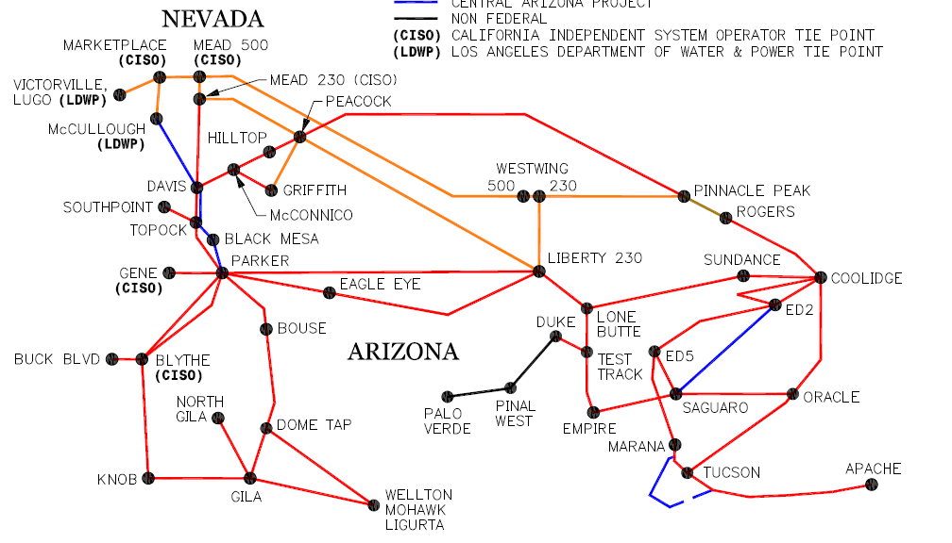
Figure 6) The WAPA transmission system within the WALC
The resources that aren’t locally generated must all be delivered via high voltage transmission lines to the Rogers Substation in order for Mesa to utilize those resources. Beginning in 2008, Mesa historically held two firm point-to-point transmission contracts with WAPA, however, in October 2018 Mesa elected to switch its largest transmission contract to a different service known as Network Integrated Transmission Service (NITS). Through NITS, Mesa only pays for the transmission that it uses at any given time. Mesa also reduced its smaller transmission contract from 25 MW to 15 MW. Recently, WAPA underwent a process to combine its transmission systems which allowed Mesa to combine its transmission contracts and now Mesa receives all its resources through its NITS transmission rights except for its federal hydroelectric power resources which are contractually delivered directly to the Rogers substation. This migration to NITS transmission has saved customers significant amounts of money since transitioning; however, caution must be maintained to ensure that costs don’t escalate. Another risk is that if WAPA has to impose significant upgrades to the transmission system, Mesa would be required to pay for a proportionate share for those upgrades. Upgrades haven’t been proposed by WAPA since Mesa’s transition to NITS, however, Mesa will continue to work with WAPA to minimize or avoid any such upgrades.
In addition to saving significant amounts of money for customers directly by cutting costs, the switch to NITS is saving Mesa’s customers significant amounts of money indirectly because it opens up Mesa’s options for power deliveries. Mesa’s previous point to point transmission contracts only provided access to the Pinnacle Peak 230 kV and West Wing 500 kV substations. Through NITS, Mesa has obtained significant access to the Mead 230 kV substation which is one of the most liquid trading hubs in the southwest (meaning that many market counterparties are willing to bid on Mesa’s business at this trading hub). Trading at Mead has significantly reduced the cost of power for Mesa’s electric supply.

Section 4.0 – The IRP Process & Goals
The planning process used by Mesa to develop this IRP is similar to the approaches used by many utilities. Mesa’s planning process and the IRP have also been developed and will be administered to fully comply with the applicable federal regulations and exceed prudent utility management practices. Mesa’s objective is to develop an IRP that is robust, flexible and economical while complying with WAPA’s requirements.
- The IRP is robust in that a number of scenarios for assumptions that significantly impact the resource choices are analyzed so that Mesa has confidence that the IRP will be a “least cost plan” under a wide variety of actual circumstances.
- The IRP is flexible in that the plan to acquire the selected resources can be accelerated or delayed if actual circumstances and conditions are materially different than those assumed in the development of this plan.
- The IRP prescribes the comparison of the costs of renewable resources to the costs conventional, long-term contractual resources that Mesa has historically utilized.
- The IRP is economical in that DSM resources have been evaluated and compared with alternative supply-side options with consideration for Mesa’s staffing resources.
- The IRP provides an economical approach in that the supply side resources will be acquired through a competitive solicitation process ensuring that the least cost source of supply (without compromising reliability) will be acquired. Mesa will use present worth and system optimization techniques to compare the various options to determine “least cost”.

The IRP achieves these objectives and will increase Mesa’s opportunities to enhance reliability by further diversifying its resource portfolio through the acquisition of resources from the competitive regional energy markets through competitive solicitation and the implementation of DSM programs that aim to increase customer interaction, reduce peak demand and leverage Mesa’s Advanced Metering Infrastructure (AMI) project. Mesa also retains the ability to pursue the development of its own resources absent the availability of economically advantageous resources from the regional energy markets.
The main principles of Mesa’s IRP approach are:
- Customer / community participation
- Resource requirements forecasted, planned & acquired in a timely & efficient manner
- Renewable & conventional supply-side options are identified through a competitive RFP process and are compared with DSM using industry standard techniques
- Resource options are selected & acquired based upon defined planning & selection criteria
- Compliance is achieved with requirement of power supply contracts and federal regulations administered by WAPA
Other objectives integral to this IRP are:
- Enhance Mesa’s ability to provide electric utility services to its customers in a safe, reliable, affordable and sustainable manner, consistent with sound utility business principles;
- Contribute to customer financial stability by providing electric power at rates that allow for continued long-term enhancement in property and asset values;
- Identify the need and timing of new resources and develop an optimal planning strategy that responds to the inherent risks in the energy marketplace.
- Provide a resource portfolio that accounts for the desires of Mesa’s customers and Council in terms of renewable resources and DSM programs.
- Actively attempt to acquire renewable resources without causing negative bill impacts to those customers who cannot or are not willing to absorb the impact from those acquisitions.

Section 5.0 Customer Requirements and Resource Needs Forecast

5.1 – Overall System Load Forecast
Mesa’s 2025-2030 peak demand and energy load forecast was developed based on recent historical load patterns on a total load basis. Demand is calculated both as registered at Mesa’s Rogers Substation point of delivery for its power resources and on a “gross” basis which attempts to back out the effects of Mesa’s internal solar generation. Mesa uses advanced forecasting techniques such as multi-variate regression analyses of weather normalized customer sales as billed and by class, and also forecasts based on the identification of discrete commercial developments and their projected electrical requirements within the ESA.
The following graph illustrates the historical demand and energy loads and growth trends in peak demand since 2003 and the projected demand and energy loads based on forecasted peak demand growth for -2025-2030.

Figure 7) Annual Peak Demand at load and at Rogers (MW). All numbers for 25/26 and later are projections.

5.2 – Customer Profile
Mesa’s ESA is unique when in comparison to neighboring utilities in that Mesa’s ESA is landlocked with no room for outward expansion. As such, any growth in Mesa’s ESA must come from infill of vacant parcels (e.g. re-development or re-use) or expansion of existing facilities. The ESA is experiencing a steady flow of infill growth in the downtown area, so growth is forecasted within the ESA as long as the overall economic climate of the area remains positive. Mesa’s downtown is also experiencing development of taller vertical spaces as well.
As a whole, Arizona experienced a high level of growth in electricity sales during the period of overall economic prosperity in the early 2000’s, however, from 2007 to 2008, this trend began to reverse and sales dropped through 2010. Since 2010, overall sales have shown slow continued growth. Arizona’s highest demand for electricity occurs during summertime. Net summer capacity in Arizona has increased from 26,392 MW in 2010 to 29,885 in 2023, a 13.2% increase. Growth can be attributed to increased population and industrial growth, including data centers.

Figure 8) Total Electricity Sales in Arizona (MWh) by Year. Residential Sales and Commercial Sales are also displayed [Energy Information Administration Form 861]. Transportation Sales (electric vehicles) comprised of 0.01% of annual sales in 2023 and so is not visible on the graph.
In addition, energy efficiency and federal policies have been steady forces shaping energy use and supply.
In 2020 President Donald Trump signed into law the Energy Act of 2020 which created new requirements for federal agencies. This implemented standards aimed to improve the energy efficiency of government facilities in a cost effective manner based on lifecycle cost analyses.
In 2021 President Joe Biden signed into law the Infrastructure Investment and Jobs Act (Infrastructure Act). The Infrastructure Act provided funding for innovative climate and energy projects and also authorized $550 million for the Energy Efficiency and Conservation Block Grant Program.
In 2022 President Joe Biden signed into law the Inflation Reduction Act (IRA) which extends the 30% Investment Tax Credit (ITC) and the Production Tax Credit (PTC) of $0.0275/kWh. For projects placed into service past 2025, the incentive structure is bifurcated between systems less than or greater than 1 MW-AC and the Clean Electricity Production Tax Credit and the Clean Electricity Investment Tax Credit will replace the historic ITC and PTC. The IRA also created a fundamental shift in how these benefits of renewable energy can be realized through “direct pay” and “transfer” options that allow tax-exempt entities to receive the federal benefits without having to rely on receiving the benefits through a PPA. The IRA provides for energy efficiency incentives as well with up to $3,200 of tax credits for home owners for improvements such as exterior doors, exterior windows or skylights, insulation and air sealing materials, home energy audits, central air conditioners, furnaces, and heat pumps.
Beginning January 2023, Department of Energy’s amended minimum efficiency standards require that all residential air conditioners sold in the United States have a Seasonal Energy Efficiency Ratio (SEER) of 14 or greater in the northern part of the US and 15 or greater in the southern part of the US. Mesa’s peak system demand, occurring in the hot summer months, is mostly driven by residential air conditioning load, so increases in required efficiency will continue to play a significant role in the reduction of Mesa’s peak demand as legacy models are replaced with the new, higher efficiency models.
In 2024, the Arizona Governor’s Office of Resiliency launched Phase 1 of the new statewide Efficiency Arizona program. Efficiency Arizona is aimed at increasing energy efficiency, promoting clean energy, and saving residents money on energy. Efficiency Arizona is funded by the Department of Energy and is part of a broader national effort that was initiated by the Inflation Reduction Act signed in 2022.

The trend of a reduction in energy use per capita can be seen in the trends in Mesa’s two largest customer classes. Residential customers’ (48% of Mesa’s FY23/24 retail sales) per-capita consumption peaked in the early 2000’s, decreasing to a low in the 14/15 fiscal year. Since then, per-capita consumption climbed through fiscal year 21/22 but has since decreased again and has overall changed very little over the past ten years.

Figure 9) Annual kWh use/residential customer by fiscal year for residential electric customers in Mesa’s ESA, weather normalized.
General Service customers’ (also known as “Commercial Customers”, comprising 36% of Mesa’s FY23/24 sales) annual consumption per customer has followed a trend of increasing through fiscal year 2006 and 2007, respectively, but began to decrease afterwards and has decreased consistently since then.
The general downward trend demonstrates in these major customer classes that customers are already able to and willing to reduce their energy use patterns without any incentive-based programs.

Figure 10) Annual kWh use per commercial customer by fiscal year for commercial customers in Mesa's ESA, weather normalized.

Section 6.0 Resource Options
The electric utility industry is in a state of flux. The conventional model of a central, large utility power plant supplying all the electricity to a collection of silent customers is shifting by the wayside towards a more decentralized, bi-directional grid with more interaction between the utility and the customers. With renewable energy pricing falling to levels where renewable energy resources are now very competitive with conventional resources, utilities are now undertaking the challenge of determining how to provide customers with the energy that they want in a manner that is as inexpensive as possible while still maintaining overall grid reliability. Those renewable energy resources, however, must be supported by dispatchable and reliable resources that can provide support for renewable intermittency and also “pick up the load” when the sun sets in the evening or the wind dies down.
Mesa has found that there are three major challenges to providing both conventional and renewable resources to its customers:
- Size: Renewable energy projects and conventional energy projects must be of appropriate size (100 MW or greater) to capture economies of scale, otherwise pricing increases significantly. Mesa is investigating creative approaches to overcoming this challenge.
- Location: Any renewable energy project or conventional energy project that Mesa wishes to participate in must be located in close proximity to Mesa’s existing transmission rights. If not, additional transmission costs can make an otherwise economical project fall out of favor very quickly. Starting in October 2018, Mesa switched to Network Transmission Service with WAPA; greatly increasing Mesa’s reach in terms of where it can procure power and so this will assist in overcoming this challenge.
- Timing: Any renewable energy project or conventional energy project that Mesa wishes to participate in must be scheduled to come online at a time that coincides with another one of Mesa’s energy supplies expiring. Mesa has strategically staggered its energy supplies so it is in a good position to overcome this challenge. With the execution of the three new electric power contracts that will begin in 2025, Mesa has continued to diversify suppliers and stagger contract expiration dates so Mesa remains in a good position to participate in renewable or conventional energy projects as they come online.
With these challenges in mind, Mesa has identified the following available energy resource options.

6.1 – Market-Based Contractual Conventional Resources
These resources are typically one to five-year long contracts between Mesa and energy suppliers for “WSPP Schedule C” firm energy products that are delivered to hubs on the Western Area Power Administration’s transmission system where Mesa has transmission rights. Prior to 2012, (aside from its two hydroelectric power contracts) Mesa provided all the energy for its electric utility using market-based contractual conventional resources from one sole provider. Since 2012, Mesa has worked diligently to seek additional qualified counterparties to purchase energy from and is now “enabled” with seven major suppliers which has helped to substantially reduce cost for Mesa’s electric utility customers.
These market-based contractual conventional resources are not source specific in that neither Mesa nor the supplier requires the energy to come from a specific power plant. The resources are simply an aggregation of energy that the supplier sources from various power plants and delivers to Mesa with the guarantee of the price and firmness of the energy, meaning that if the supplier cannot deliver, it is responsible for paying Mesa damages.
In Mesa’s 2024 IRP, it will be assumed that Mesa will still be able to purchase market-based contractual conventional resources indefinitely without any limits on capacity availability.

6.2 – Utility Scale Renewable Resources
Renewable resources have dropped in price substantially to where they are competitive with or less expensive than conventional resources, however, due to the variability of the resources and lack of dispatchability, renewable resources still pose significant integration challenges without storage. The industry standard currently, however, is that storage capacity is generally constructed alongside most renewable energy projects. Mesa’s ability to procure renewable resources at a low cost, however, is limited because low priced renewable resource typically require a minimum of 100 MW of installed capacity and Mesa cannot commit to anywhere near that level of a purchase. As such, Mesa must be flexible and ready to embrace opportunities where it can be a secondary participant in a larger project to capitalize on economies of scale and not overcommit to a level of resources that are beyond the electric utility’s ability to absorb.
Additionally, any renewable energy project that Mesa wishes to participate in must be located in close proximity to Mesa’s existing transmission rights. If not, additional transmission costs can make an otherwise economical project fall out of favor very quickly. Starting in October 2018, Mesa switched to Network Transmission Service with Western; greatly increasing Mesa’s reach in terms of where it can procure power and so this will assist in overcoming this challenge.
Lastly, any renewable energy project that Mesa wishes to participate in must be scheduled to come online at a time that coincides with another one of Mesa’s energy supplies expiring. Mesa has worked to stagger its energy supplies so it is in a good position to overcome this challenge.
Utility-scale energy resources can generally be broken up into the following categories:

6.2.1 Market Purchased Solar Energy:
Mesa, with access to multiple transmission systems, is well situated to procure solar energy from across the desert southwest, and so Market Purchased Solar Energy remains one of Mesa’s best options for procuring renewable energy. Additionally, these solar generators are often installed as single axis tracking technology which significantly increases their capacity factor to better fit Mesa’s load shape. Benefits of Market Purchased Solar Energy include:
- Often the least expensive solar power option
- Output of single axis tracking systems better matches Mesa’s summer load profile
- A third-party vendor is generally responsible for establishing site control, establishing interconnections; is responsible for the maintenance and operation of the system; and is responsible to ensure that the system is outputting an optimal amount of energy
- No land is required to be given up in Mesa’s Electric Service Area
Drawbacks of Market Purchased Solar Power include:
- These projects are often constructed far away from Mesa, therefore they don’t provide a visual, tangible indication of Mesa’s efforts towards sustainability
- Losses and transmission costs can “pancake” (layering costs and losses on top of each other every time a new transmission system is used), reducing the cost benefit of the projects
- Complex transmission arrangements can be difficult to administer

6.2.2 Market Purchased Wind Energy:
Similar to Market Purchased Solar Energy, there may be opportunities for Mesa to procure Market Purchased Wind Energy. There are far fewer wind projects being installed in comparison to the number of solar power projects being installed in the southwest. Like utility scale solar projects, it is difficult for Mesa to take part in wind power projects because Mesa’s small demand for wind power takes a backseat to the larger participants in the wind project who will dictate whether or not the project ultimately gets developed and the timeline of when this occurs. Manufacturers are continually increasing the size of the latest wind turbines to where single (offshore) wind turbines can be in the 20 MW and above range and so this makes trying to source 10 MW of wind power very difficult. Wind power developers are typically looking for utilities who want 100 MW or more as their anchor capacity off-take from these projects.
Although wind energy hasn’t seen the consistent decline in prices that solar has seen, some wind power PPA’s are extremely competitive with conventional energy. The closest wind resources that Mesa has access to would be generated in either northern Arizona, or in New Mexico. New Mexico generally has higher capacity factors than northern Arizona, so the biggest challenge for Mesa is finding a project to which it can secure transmission access.
Benefits of wind energy include:
- Historically the least expensive option to procure renewable energy until recently
- Projects in New Mexico have very high capacity factors in comparison to solar power
- No land is required to be given up in Mesa’s Electric Service Area
- Certain wind profiles compliment Mesa’s load shape very well (Eastern New Mexico)
Drawbacks of wind energy include:
- The load shape of some wind power projects can be the opposite of Mesa’s load shape (wind peaks generally at night and during the winter)
- Wind energy projects are located very far away from Mesa, therefore, Mesa runs the risk of having to purchase transmission across multiple transmission providers, significantly increasing transmission costs and losses

6.2.2 Other Market Purchased Renewable Resources:
Through Mesa’s RFP’s, other renewable technologies have also been submitted. Geothermal energy, while not readily available in Arizona for power generation, is abundant in the Salton Sea area of California, in Nevada and in some areas of Utah as well. SRP is purchasing renewable energy from the 25 MW from the Cove Fort Geothermal Project in central Utah and both APS and SRP are purchasing power from geothermal generators in the Salton Sea area.
Biomass power, where wood or wood byproducts are burned to generate power, has a small presence in Arizona, but Mesa has not received any offers for Biomass power in any RFP’s and there are no known Biomass power plants being developed.
Through competitive solicitation, Mesa can continue to check the market for these and all other renewable energy resources and so if they are available, they can be evaluated alongside other resources appropriately.

6.3 – Local Conventional Resources
Mesa has been active in analyzing opportunities to install generation within its ESA to serve multiple purposes:
- As Mesa’s customers’ peak electric demand grows, Mesa will have to decide how to avoid exceeding 133 MW of demand at Rogers; internal generation is one way to reduce the resources required at Rogers.
- Increasing emphasis is being put on disaster readiness. Having internal generation capacity would allow the City to power critical infrastructure in the event of a utility outage.
- Favorable natural gas prices and more competition in the market for small-scale generators has made natural gas-powered megawatt-scale generation more competitive with large scale generation (although small-scale generation is still more expensive than large scale generation)
- These generators (depending on the technology) can be ramped up very quickly to respond to shortfalls in renewable resource generation and therefore help avoid penalties associated with renewable resources failing to deliver
Technologies that are considered include:
Table 4) Generation technologies considered
Technology | Size per Unit | Typical Manufacturers | Time: Startup to Full Load | Heat Rate (HHV)
Internal Combustion Engines | 800 kW – 12 MW | Caterpillar, Wartsila, Jenbacher | 5 minutes | 8,000 Btu/kWh – 11,000 Btu/kWh
Combustion Turbines | 6 MW - 35 MW | Solar Turbines, GE, Capstone | 25 minutes | 11,000 Btu/kWh

Changes in local air quality within Maricopa County have constrained the opportunity for Mesa to install conventional resources within (or near to) Mesa’s ESA, however, some opportunities still exist and will be evaluated as part of this IRP.

6.4 – Local Renewable Resources
Since the 2019 IRP, Mesa has gained experience in installing renewable resources within the ESA. This continues to be a resource option for Mesa going forward as there are still plenty of remaining parking lots, parking garages, rooftops and other areas that could accommodate solar installations. Utility owned distributed solar energy has many benefits including:
- No distribution revenue reduction or cross subsidization among customer classes
- A third-party vendor is generally responsible for the maintenance and operation of the system and is responsible to ensure that the system is outputting an optimal amount of energy
- Sites are generally more optimal for generation than customer-owned PV sites and therefore can see higher capacity factors
- Minimizes losses by siting generation close to load
- Projects at prominent City facilities serve as a visual example of Mesa’s efforts towards sustainability
- Projects can serve multiple purposes including:
- The creation of event spaces underneath solar canopies
- Creating covered parking at facilities where the public and city employees park
- Providing energy for a community solar program
- Mitigates Urban Heat Island effect by (typically) covering dark asphalt surfaces
- Can be sited (along with storage) to help support voltage or frequency in problem areas within the distribution utility
Drawbacks to utility owned distributed solar energy include:
- Generally, a higher cost than a utility scale, market-based renewable energy purchase
- Can occupy space that may be required later for other City projects or may occupy space that the City may wish to sell at a later date
The ancillary benefits of installing utility-owned, distributed solar generation help to make this a more attractive option for procuring renewable energy, however, the extra cost premium of this option when compared to larger utility scale projects must be justified through those ancillary benefits.

6.5 – Customer Resources

6.5.1 Customer Solar Resources
Mesa has extensive experience with small scale solar installations throughout its various utilities and implemented its Solar PV Pilot Program in July of 2012. Since then, over 2,300 kW of customer-owned solar systems have been installed (approximately 190 kW per year). Data from the program has shown that fixed axis solar PV in Mesa generates approximately 1,680 kWh per kW-DC, for a capacity factor of 19.2%. Customer-owned solar PV has many benefits to Mesa such as:
- Mesa does not have to provide a site for the solar panels
- Mesa does not have to operate or maintain the solar panels, inverter(s) and associated equipment
- The solar panels are sited at the point of electric consumption, minimizing losses
Despite these benefits, Mesa’s experience with customer-owned solar has revealed drawbacks such as:
- Reduction in revenue from reduced electricity sales
- Customers are at risk of complex contractual provisions that often cannot be negotiated with solar installers
- Cross subsidization from non-solar PV customers to solar PV customers (for net metering)
- Customers are responsible for maintaining trees on site to ensure that the systems generate energy; many of the customers have trees which interfere with their solar generation
- Customers may alter their solar system after installation which may put the safety of the installation at risk
- In total, customer-owned solar has been more expensive, per kWh, than quotes for other renewable resources
- Mesa devotes significant Energy Resources staff time to the safe installation of these systems
. Other utilities’ IRP’s forecast a consistent growth in customer-owned solar resources and so Mesa envisions that it will also see consistent growth of the customer-owned solar program.

6.5.2 Customer Battery Resources
Mesa successfully interconnected its first customer-owned battery installation in January 2019 and since then has interconnected a total of 202 kW of battery capacity. These installations benefit Mesa in that they can, in the future, be used as a resource in a Virtual Power Plant to charge during hours when power is plentiful (solar hours or nighttime hours) and discharge during hours of peak demand. Mesa’s program allows customers to increase their solar PV size from 5 kW to 10 kW to maximize the benefit of being able to store the energy and provide it to the utility during times when it’s needed the most.

6.5.2 Virtual Power Plant Resources
A Virtual Power Plant is the aggregation of a number of small (often unconventional or customer-side) resources to combine them into a single larger resource that acts in unison. As a result of Mesa’s All-Source RFP in spring of 2021, Mesa learned that there are vendors capable of providing Virtual Power Plant Resources within Mesa’s ESA and that the resource could be significant. Following this, Mesa released another RFP specifically for Virtual Power Plant Services and that RFP was awarded to Virtual Peaker. Since successful implementation in summer of 2023, Mesa has added 96 customers to the program through the use of their smart thermostats. This represents the ability to reduce Mesa’s summer peak demand by approximately 500 kW whenever an event is called. Mesa has been actively marketing and growing this program and it is expected to grow in enrollment through the IRP period. Virtual Peaker’s platform does allow for the integration of other devices such as EV chargers and customer-owned battery installations.

6.5.3 Demand Side Management Resources
Mesa has worked with consultants and performed internal analyses to determine the benefits of Demand Side Management (DSM) programs throughout its past three IRP periods. The results of these study indicated potential to reduce summer peak demand by implementing certain DSM programs but do also carry the burden of significantly increased administrative efforts. The following technologies were considered due to 1) their use in other Arizona utilities’ DSM programs and 2) their potential to reduce demand during peak consumption hours (certain DSM measures wouldn’t affect peak hour demand and, as such, were discarded from further analysis):
Residential Demand Side Technologies Considered

Room Heating/Cooling
- Duct Testing and Repair
- High Efficiency AC Upgrade
- Smart thermostats

Thermal Envelope
- Shade Screens

Rates
- Time of use rates
- Pay as you go rates

Customer Sourced Energy
- Customer-owned storage
- Customer-owned solar with storage
- Customer-owned solar

Other
- Shade Trees
- Pool Pump Upgrade
- Energy audits

Commercial Demand Side Technologies Considered

- Commercial “Standard” Demand Side Management
- Commercial Custom Energy Solutions
- Commercial Energy Audits
- Commercial solar

Other Demand Side Management Technologies Considered

- Municipal Energy Efficiency Upgrades
- Electric Vehicle Incentives
- Electric Vehicle Charging Rates
- Multifamily Efficiency Program
- Cogeneration
- Energy Storage

While Demand Side Management measures can reduce peak system demand, it should be noted that DSM measures can also reduce the total sales of energy, reducing the revenue contribution of each customer who has the means to implement such DSM measures. When measuring and evaluating the impact of DSM measures and their suitability for implementation, the balance of the benefits and costs associated with each measure are calculated using the Total Resource Cost Benefit Ratio (TRCBR). If the TRCBR is greater than 1.0 then the DSM measure can be considered to have more benefits than costs and would therefore be worth implementation.

Section 7.0 Public Input
The IRP process for Mesa’s 2024 IRP began early with the development of an online survey which sought to evaluate Mesa’s customers’ appetite for renewable resources, appetite for demand side management programs and tolerance for any associated rate increase as the result of acquiring those renewable resources.
To better gauge Mesa’s customers’ perception of renewable energy, Mesa created an online survey that was sent out to customers in its service territory. At the end of that survey, in September 2024 the survey received 167 responses from Mesa customers that provide direct insight into customers’ willingness to pay for renewable resources:
If Mesa provides you with more renewable energy, this may involve more costly resources (compared to the current energy that COM provides). Which of the following choices below characterizes your support of the use of renewable power:

I am not willing to pay an increase in my utility energy bill for renewable resources | 32.9% | 55
I am willing to pay a 1-2% increase in my utility energy bill if some of it could come from renewable resources | 28.7% | 48
I am willing to pay a 2-5% increase in my utility energy bill if some of it could come from renewable resources | 19.2% | 32
I am willing to pay a 5-10% increase in my utility energy bill if some of it could come from renewable resources | 8.4% | 14
I am willing to pay a 10-20% increase in my utility energy bill if some of it could come from renewable resources | 5.4% | 9
I am willing to pay a 20-40% increase in my utility energy bill if some of it could come from renewable resources | 2.4% | 4
I am willing to pay whatever bill increase that it takes to maximize the renewable resources that provide my energy | 3% | 5
Total |  | 167

From this first question, it is clear that a large portion of respondents (32.9%) do not want to pay more for their energy in order to receive renewable resources; however, a larger portion (67.1%) of respondents were willing to pay more for their energy at varying levels with interest tapering off as the increase escalates.
In terms of what is most important to the customers, Mesa proposed the following ranking question:
How would you rank the following from 1 to 3 regarding the importance to you with 1 being the most important?

Option | Average Rank
Cost of Electric Service | 1.87
Electric Service Reliability | 1.95
Environmental Considerations for Mesa’s electrical power supply sources | 2.05

This question showed that the cost of the customers’ bills is most important to them with reliability closely in second and sustainability considerations closely in third. Although this question highlights the difficult choices that must be made in terms of making resource choices, it does provide insight into customer concerns and priorities.
Mesa also sought input into customer’s trust in the reliability of both the southwestern power grid and the reliability of the grid in the Phoenix-Mesa valley:
Do you consider the southwestern power grid to be reliable (areas including Arizona, New Mexico, Nevada and California)?

Option | Average Rank
Yes | 111 (66.5%)
No | 13 (7.8%)
Not sure – I will need additional information to form an opinion | 43 (25.7%)

Do you consider the power grid in the Phoenix-Mesa valley to be reliable?

Option | Average Rank
Yes | 139 (83.2%)
No | 6 (3.6%)
Not sure – I will need additional information to form an opinion | 22 (13.2%)

Mesa also asked respondents whether or not they specifically track their electricity bill or the total bill from the City:
Do you track your electric bill on a monthly basis?
Option | Average Rank
Yes, I track my monthly electric bill | 97 (58.8%)
No, I do not track my electric bill | 8 (4.8%)
I track my total City of Mesa bill (electric, water, wastewater, solid waste service etc. on a monthly basis. | 60 (36.4%)

This indicates that the customers taking the survey are particularly concerned with their consumption and/or bill amounts as the vast majority of them are tracking either their electric bill or all of the bills they receive from Mesa.
Because energy efficiency tends to be implemented organically as appliance standards increase and old equipment is retired from service, Mesa asked the customers about what energy efficiency upgrades they have already implemented. Out of 153 responses, the following energy efficiency upgrades have been implemented:
Option | Number of Customers Responding
Upgraded to LED Lightbulbs | 109
Installed a “smart” thermostat | 50
Installed dual pane or other high efficiency windows | 49
Replaced the air conditioner in the last 5 years with a high efficiency model | 44
Installed shade screens over the windows | 43
Added a tree to the property to shade the building | 35
Upgraded to CFL Lightbulbs | 34
Replaced the air conditioner in the last 5 years with a standard model | 33
Upgraded insulation in the attic or walls | 31
Repaired leaky or otherwise broken air conditioning ducts | 30
Installed UV blocking solar window film | 20
Installed solar panels | 11
Had an energy audit | 11
Installed a high efficiency pool pump | 10
Other (please specify) | 8

Out of the 153 responses, the majority of respondents have replaced their light bulbs with more efficient LED bulbs. Other efficiency measures haven’t been as strongly adopted but approximately a third of the respondents have installed a smart thermostat and/or installed high efficiency windows. Least popular were a high efficiency pool pump, energy audits or installing solar panels.
Mesa attempted to gauge interest in what demand side programs would be attractive to customers and the following responses were gathered out of 157:
What energy efficiency programs would you use if the City of Mesa Electric Utility implemented them? (check all that apply)
Option | Number of Customers Responding
Shade tree program | 70
Low-cost window shade screens | 67
Incentive to upgrade air conditioner to a high efficiency model | 59
Incentive for high efficiency appliance upgrades (i.e. high efficiency refrigerator or washer/dryer) | 55
Low-cost air conditioning duct testing | 55
Low-cost energy audits | 50
Incentive for a smart thermostat | 50
Incentive for solar photovoltaic (PV) system | 46
Incentive for solar water heating | 42
Incentive for battery storage | 39
Incentive for high efficiency pool pumps | 18
Other (please specify) | 8

Through this question, respondents provided the feedback that a shade tree program and options for low-cost window shade screens are most favorable.

Section 8.0 – Considerations in Selecting a Resource Portfolio

8.1 – Alignment with Customer Sourced IRP Feedback
The criteria most important to Mesa’s customers has historically been the economic impact to the customers’ bills and this was demonstrated through the customer survey explained earlier in this report. As mentioned previously, Mesa maintained an extremely low aggregate cost of power prior to the southwest’s capacity “crisis” in the summer of 2020. With that causing an extreme escalation in Mesa’s aggregate cost of power (nearly tripling the annual cost), customers have provided extensive feedback that cost is the most important factor in selecting supply portfolio options. When evaluating the scenarios going forward, any supply portfolios that put undue upward pressure on projected supply costs will not be viewed favorably. As discussed above in Section 7, Mesa’s customers wish to have a balanced evaluation of cost impact, reliability impact, and sustainability impact, in that respective order. Mesa will continue to integrate these evaluation criteria into this IRP and future resource choices. Reliability and Sustainability were seen as almost equally as important as maintaining cost competitiveness and so will also be considered highly important in the evaluation of any scenarios, but were ranked slightly lower.

8.2 – Alignment with City Management and Council Goals
Mesa’s electric utility, which is not under the jurisdiction of the Arizona Corporation Commission (ACC), is not subject to the ACC’s Renewable Energy Standard and Tariff (REST) which requires that Arizona utilities meet 15% of their annual energy requirements with renewable resources by 2025. Mesa City Council, however, enacted Mesa’s Climate Action Plan (MCAP) in June of 2022. The MCAP has aspirational goals that will guide the direction of the electric utility. The MCAP’s goal related to greenhouse gas emissions from City Operations is a reduction by 50% by 2030; the goal for 2050 is full carbon neutrality; and the goal for renewable energy by 2050 is 100% in addition to other goals:
Figure 11) High level goals of Mesa's Climate Action Plan
Within the context of the MCAP, Mesa must now evaluate its electric supply resource choices within the context of achieving these goals.
As a whole, the electric industry has been reducing Carbon Dioxide intensity (measured in CO2 output per unit of energy generated) as the industry shifts from high carbon intensity coal generation to lower carbon intensity natural gas generation, renewable resources, and energy storage. As Mesa has progressively added more renewable energy resources and continues purchasing energy from a grid with a decreasing carbon intensity overall, Mesa’s carbon intensity for electric generation has also decreased. This organic decrease in carbon intensity will help Mesa to achieve its 2030 and 2050 MCAP goals:
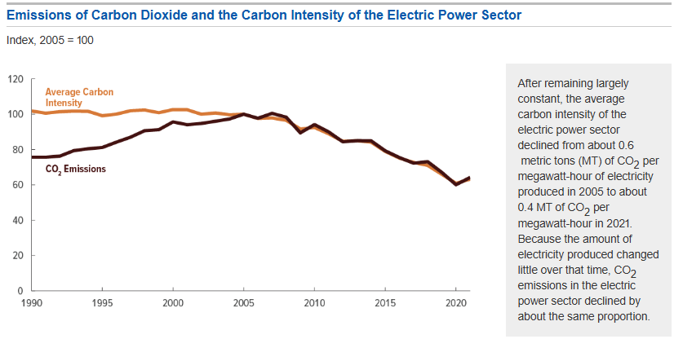
Figure 12) Overall carbon emissions from the electric power sector of the United States. Aside from the uptick following the pandemic, carbon emissions in the United States have generally been falling since the mid-late 2000’s.

8.3 – Alignment with Department Goals
The Energy Resources Department maintains the goal of delivering Safe, Reliable, Affordable and Sustainable energy to its electric customers. These goals have served as guiding principles for all the decisions that the department has made to create and maintain a successful electric utility for over a century. Scenarios will be evaluated in terms of their ability to meet these goals.

Section 9.0 – Proposed IRP Scenarios
Three portfolio scenarios have been evaluated in the context of the selection criteria. The scenarios represent three feasible paths forward for Mesa that would create different outcomes in terms of the resources chosen, however, all the scenarios share commonalities in that they all:
- Focus on providing stable pricing for Mesa’s customers
- Retain a focus on “least cost” competitive procurement for their individual constraints
- Focus on providing a reliable supply of electricity to Mesa’s customers
- Seek to create adaptability to react to changing market conditions
- Continue to use an approach that doesn’t oversubscribe Mesa to any individual resource
- Seek to meet sustainability goals required by Mesa’s City Council
All scenarios take the same approach to Customer Energy Resources, Mesa’s hydroelectric generation resources and “System Reliability and Transmission” but then all differ slightly for the other aspects of Mesa’s electric supply portfolio. The scenarios are summarized here:
Table 5) IRP Scenarios considered for evaluation. This table is replicated in the executive summary.
Portfolio Metric | Preferred Scenario: Least Cost Mix of Conventional & Renewables Portfolio | Alternative Scenario 1: Conventional Resources Portfolio | Alternative Scenario 2: Solar/Renewable Focused Portfolio
Contract Replacement Strategy | Mesa would focus on replacing its expiring conventional, wholesale-market-based term contracts with a mixture of similar, conventional resource-based term contracts based on economics as measured by the present worth of costs and applicability. Contracts will be staggered to avoid simultaneous market exposure of more than two resources at one time.  Contracts would be phased out as other resource acquisitions (renewable or conventional) are put into place and reach COD. | Mesa would focus on replacing its expiring conventional, wholesale-market-based term contracts with a mixture of similar, conventional resource-based term contracts based on economics as measured by the present worth of costs and applicability. Contracts will be staggered to avoid simultaneous market exposure of more than two resources at one time.  Contracts would be phased out as other resource acquisitions (typically conventional) are put into place and reach COD. | Mesa would focus on replacing its expiring conventional, wholesale-market-based term contracts with a mixture of similar, conventional resource-based term contracts based on economics as measured by the present worth of costs and applicability. Contracts will be staggered to avoid simultaneous market exposure of more than two resources at one time.  Contracts would be phased out as other resource acquisitions (typically renewable) are put into place and reach COD. Mesa would solicit and pursue offers for RECs to modify these resources to be carbon free until they can be replaced by carbon free resources with true “additionality”
Renewable Resource Acquisitions | Renewable resource acquisitions would be timed to maximize the benefits of tax advantages and drops in market pricing. Resources will be evaluated for their economic impact and only pursued if providing an economic benefit or very limited negative economic impact. | Renewable resources would only be acquired in the instance that they provide substantial savings compared to conventional resources and solely at a pace to meet MCAP minimums. | Renewable resource acquisitions would be acquired as available to maximize the amount of renewable resources integrated into the electric supply portfolio. Resources will be evaluated for their economic impact and would be pursued if providing an economic benefit or very limited negative economic impact.
Energy Efficiency | Demand side management programs would be developed based on available staffing resources, industry standard benefit-cost tests including consideration of resources needed to effectively and efficiently implement the programs. AMI enabled rate structures will be pursued at the pace currently recommended by staff. | Energy efficiency programs would be eliminated or limited solely to pricing/rate-oriented initiatives such as time of use rates that are becoming feasible with Mesa’s conversion to AMI. | Demand side management and energy efficiency programs would be maximized based on industry standard benefit-cost tests. AMI enabled rate structures will be pursued at the pace currently recommended by staff.
Internal, Utility-Owned Generation | Internal generation (natural gas, renewable, storage based or some combination of those) would be added as feasible to help provide additional reliability for critical infrastructure, hedge against market fluctuations and support grid reliability and renewable resources. | Internal generation (natural gas, storage based or some combination of those) would be added as feasible to help provide additional reliability for critical infrastructure, hedge against market fluctuations and support grid reliability. | Internal generation (natural gas, renewable, storage based or some combination of those) would be added as feasible to help provide additional reliability for critical infrastructure, hedge against market fluctuations and support grid reliability and renewable resources with renewable resources being prioritized at sites with significant land resources within the ESA.
Renewable Generation and Storage at City Facilities | Renewable generation at City facilities would be implemented as deemed economical to provide other benefits that market-based resources do not provide (e.g. shade and community development) alongside the benefit of local power generation.  City sites that are unusable for other purposes will be evaluated for energy storage and/or microgrid resources. | Renewable generation at City facilities would be limited to the current installed capacity to maximize local renewable generation as limited by available staff and project management resources.  City sites that are unusable for other purposes will be evaluated for microgrid resources with minimal focus on energy storage resources. | Renewable generation at City facilities would be implemented to maximize local renewable generation as limited by available staff and project management resources.  City sites that are unusable for other purposes will be evaluated for energy storage and/or microgrid resources.
Customer Resources | The customer-owned solar program (including net metering and caps on size and total new participants) will be reviewed annually and adjusted if appropriate. With the implementation of AMI, additional rate structures would help retain the value of those resources for all customers.  Mesa will continue to refine its customer energy storage program based on lessons learned from the implementation of the first systems that have been added.  Mesa will continue its virtual power plant program and evaluate the extension of the contract with its current vendor as that approaches expiration and seek to integrate other resources (such as battery storage, and other appliances) as economical.  Electric Vehicle programs (TOU Rates) will be implemented to minimize the impact to peak demand and need for infrastructure additions.
System Reliability and Transmission | Internal demand will continue to grow, however, this will be offset through the installation of internal/distributed generation and peak demand reductions, the requirement for investments in new transmission, substation and distribution infrastructure will be avoided or delayed for substantial amounts of time. Mesa will pursue options for a second supply point/feed for the distribution system to significantly increase system reliability. Any microgrids, energy storage or internal generation projects would be designed and located to maximize the support of critical City infrastructure.  Mesa will continue to monitor available trading hubs to optimize its transmission delivery points through its Network Integrated Transmission Service (NITS) and will be in constant evaluation of whether point to point services will be required.
Hydroelectric Power Resources | Mesa’s hydroelectric allocations will be retained for flexibility and economics

9.1 – Preferred Scenario: Least Cost Mix of Conventional & Renewables Portfolio
In this scenario, Mesa will seek the least cost mix of conventional and renewable resources based on the technological and economic limits of the integration of renewable resources into the supply portfolio within the context of achieving MCAP goals and stabilizing and reducing supply costs for customers.
Mesa’s energy supply contracts will continue to be staggered to avoid simultaneous market exposure for a large portion of the supply portfolio at any given time. This staggering also positions Mesa to be able to easily shift strategies if other resources (such as a utility scale renewable energy project or the opportunity to participate in a conventional energy project) become available. Mesa will continue to seek to become enabled with additional counterparties to maximize the competition for Mesa’s business. Mesa will likely need to issue a competitive request for proposals for firm supply in fall of 2025 for at least one expiring contract that is currently held with Constellation.
Mesa will continue to pursue participation in utility-scale renewable energy projects as they become available and are economically viable. Participation in these projects hinges upon Mesa’s ability to act as a portion of the load of a larger project. Also critical to participation in these projects is Mesa’s ability to understand and negotiate complicated power purchase agreements and so external legal and consulting resources may be required from time to time. Mesa will continue pursuing a 25 MW share of the AEPCO Pinal Solar project (with a commensurate 20 MW battery energy storage capacity from the project). Mesa’s current load profile allows for a substantial amount of integration of wind power resources and a limited amount of additional solar power resources after accounting for the Pinal Solar project and so Mesa will continue to issue all-source RFPs to solicit offers for these resources. These resources, however, may require additional conventional resources to provide regulation and firming services so caution will be exercised when reviewing resources to avoid any unnecessary hidden costs of integration.
From an energy-efficiency standpoint, Mesa’s use of these resources will be limited by the availability of staffing resources. The City of Mesa’s Sustainability Department has been able to implement a tree planting program that Mesa (the electric utility) has been able to successfully leverage to plant trees for electric utility customers and this program is the most highly desired program by Mesa’s customers per the IRP survey. Mesa will continue to promote this program to customers as long as those resources are available. Additional incentive programs at this time would require additional staff or contractor resources which unfortunately has the drawback of making them infeasible. If other staffing resources become available (through other departments or grant programs) then these programs may be pursued. As a result of Mesa’s implementation of AMI, time of use rates can soon be developed for all residential and commercial customers to (voluntarily) use. Mesa has currently implemented a limited roll out of TOU rates with its Electric Vehicle Time of Use rate, but deployment of TOU rates to all customers requires much closer study and more data from the AMI meters is needed for that study. It is envisioned that Mesa will be able to recruit a consultant to study TOU rates in late 2025 for deployment of those rates in the 2027 bill cycle.
Mesa will continue to evaluate its available facilities with empty land for the suitability of generation or storage resources. Mesa’s vacant substation sites which formerly housed 69 kV to 4 kV substations will be evaluated for their potential to be used as energy storage sites and/or microgrid sites. The City of Mesa has other sites throughout the electric service area which may also be suitable for energy storage or microgrids and so these sites will continue to be evaluated for suitability.
Larger sites will be considered for larger storage and larger generation projects with the understanding that Mesa’s staff is not experienced in the operation and maintenance of such facilities. So larger sites will be more suitable for power purchase agreement/land lease structures where the City of Mesa leases the land to a developer who then sells the power back to Mesa and owns and operates the generation asset. Mesa expects to continue pursuing its current 3 MW microgrid project at the public safety campus in downtown Mesa and will be continually evaluating that project in the face of changing economics. Mesa will also continue pursuing a pilot program for approximately 200 kW of battery energy storage at one of its vacant substations in hopes of leveraging those results into additional, larger projects in the years to come.
Mesa will continue its customer-owned solar program which is growing rapidly. Net metering and caps on size and number of participants will continue to be reviewed and adjusted if appropriate. Mesa will continue its virtual power plant program (the smart thermostat program through Virtual Peaker) and evaluate the extension of the contract as that approaches its expiration. Mesa will also seek to integrate other resources (such as battery storage, and other appliances) as economical. Lastly, Electric Vehicle programs (TOU Rates) will be implemented to minimize the impact to peak demand and need for infrastructure additions including rates and program that seek to maximize charging during the daytime to leverage low-cost market power during solar peak times (such as workplace charging).
As seen in the projections in Table 6, internal demand will continue to grow, however, this will be offset through the installation of internal/distributed generation and peak demand reductions. Because of this reduction in net demand at the Rogers substation, the requirement for investments in new transmission, substation and distribution infrastructure will be avoided or delayed for substantial amounts of time. Even though the net demand at Rogers is seen as decreasing in the projection, that does not obviate the need to pursue additional reliability projects. Mesa will pursue options for a second supply point/feed for the distribution system to significantly increase system reliability in coordination with other local utilities. Any microgrids, energy storage or internal generation projects would be designed and located to maximize the support of critical City infrastructure. Mesa will continue to monitor available trading hubs to optimize its transmission delivery points through its Network Integrated Transmission Service (NITS). Currently, Mesa’s resources are focused at the Mead 230 kV and West Wing 500 kV substations which have been the most liquid and cost competitive hubs but if access opens up to more liquid hubs such as the Palo Verde hub, Mesa will evaluate shifting its transmission rights to utilize those hubs. Mesa will be in constant evaluation of whether point to point services will be required or will be otherwise more optimal than NITS services.
Lastly, Mesa will continue to leverage its hydroelectric power generation resources and will seek to renew its Parker Davis Project hydroelectric power resource in 2028. Mesa will continue to work with WAPA to secure RECs from the generation projects to provide clarity as to how much of the energy from these resources is truly renewable.
Mesa’s electric supply portfolio is projected to consist of the following resources under the Preferred Scenario:
Table 6) Projected Resource Portfolio for the Preferred Scenario
YEAR |  | 2025 | 2026 | 2027 | 2028 | 2029 | 2030
LOAD (MW) |  | 93.0 | 93.6 | 94.2 | 94.8 | 95.3 | 95.9
Demand Side & Local Resources | Dist. Utility Solar | 1.5 | 1.5 | 1.9 | 1.9 | 1.9 | 1.9
Demand Side & Local Resources | Customer-Owned Solar | 1.0 | 1.1 | 1.2 | 1.3 | 1.4 | 1.5
Demand Side & Local Resources | Microgrid Resources | 0.0 | 3.0 | 3.0 | 3.0 | 3.0 | 3.0
Demand Side & Local Resources | Virtual Power Plant | 0.8 | 1.1 | 1.3 | 1.6 | 2.0 | 2.3
Demand Side & Local Resources | Battery Energy Storage Resources | 0.0 | 0.2 | 3.0 | 3.0 | 6.0 | 6.0
Total Demand Side & Local Resources (MW) |  | 3.4 | 6.9 | 10.4 | 10.8 | 14.2 | 14.6
Net Demand at Rogers (MW) |  | 89.6 | 86.7 | 83.8 | 83.9 | 81.1 | 81.3
Supply Side Resources | Term Contracts (EEI/WSPP) | 55 | 55 | 30 | 30 | 25 | 25
Supply Side Resources | Utility Scale Solar with Storage | 0 | 0 | 25.0 | 25.0 | 25.0 | 25.0
Supply Side Resources | SRP Renewable Energy Project | 14.0 | 14.0 | 14.0 | 14.0 | 14.0 | 14.0
Supply Side Resources | Parker- Davis | 10.4 | 10.4 | 10.4 | 10.4 | 10.4 | 10.4
Supply Side Resources | CRSP | 4.3 | 4.3 | 4.3 | 4.3 | 4.3 | 4.3
Supply Side Resources | RMS Market Purch. | 5.9 | 3.0 | 0.1 | 0.2 | 2.4 | 2.6
Total Supply Side Resources (MW) |  | 89.6 | 86.7 | 83.8 | 83.9 | 81.1 | 81.3
TOTAL SUPPLY (MW) |  | 93.0 | 93.6 | 94.2 | 94.8 | 95.3 | 95.9

The Preferred Scenario falls somewhere in between Alternative Scenarios 1 & 2 in terms of renewable resources. In total, approximately 55% of Mesa’s annual electric supply (in terms of MWh) would come from renewable resources in this portfolio. Costs would be slightly less than Alternative Scenario 1 due to the implementation of low-cost solar resources as economically justified.

9.2 – Alternative Scenario 1: Conventional Resources Portfolio
In the first Alternative Scenario, Mesa would proceed, largely, in the same manner that it has historically; utilizing competitive requests for proposal to source standard market-based, conventional resource contracts and implementing renewable resources to the extent that they are technically and economically viable. In this scenario, the following would substantially differ from the Preferred Scenario in that:
- Renewable resource acquisitions would be reduced. This would reduce the volatility and uncertainty in the scheduling of Mesa’s supplies, however would cause a slight increase in overall portfolio cost. Mesa’s participation in the AEPCO Pinal Solar project would be reduced to 20 MW which would still meet Mesa’s Climate Action Plan requirements for renewable energy.
- Energy efficiency programs would be limited to rate-based programs.
- Internal conventional generation may be added but renewable energy resources within the ESA would be limited to limit cost impact. Similarly, internal energy storage resources would be minimized. In the aggregate, this would reduce the quantity of local demand side and local resources which are useful in maintaining system reliability.
Mesa’s resource supply portfolio is projected to consist of the following resources under Alternative Scenario 1:
Table 7) Projected Resource Portfolio for the Alternative 1 Scenario
YEAR |  | 2025 | 2026 | 2027 | 2028 | 2029 | 2030
LOAD (MW) |  | 93.0 | 93.6 | 94.2 | 94.8 | 95.3 | 95.9
Demand Side & Local Resources | Dist. Utility Solar | 1.5 | 1.5 | 1.9 | 1.9 | 1.9 | 1.9
Demand Side & Local Resources | Customer-Owned Solar | 1.0 | 1.1 | 1.2 | 1.3 | 1.4 | 1.5
Demand Side & Local Resources | Microgrid Resources | 0.0 | 3.0 | 3.0 | 3.0 | 3.0 | 3.0
Demand Side & Local Resources | Virtual Power Plant | 0.8 | 1.1 | 1.3 | 1.6 | 2.0 | 2.3
Demand Side & Local Resources | Battery Energy Storage Resources | 0.0 | 0.0 | 0.0 | 0.0 | 0.0 | 0.0
Total Demand Side & Local Resources (MW) |  | 3.4 | 6.7 | 7.4 | 7.8 | 8.2 | 8.6
Net Demand at Rogers (MW) |  | 89.6 | 86.9 | 86.8 | 86.9 | 87.1 | 87.3
Supply Side Resources | Term Contracts (EEI/WSPP) | 55 | 55 | 30 | 30 | 30 | 30
Supply Side Resources | Utility Scale Solar with Storage | 0 | 0 | 20.0 | 20.0 | 20.0 | 20.0
Supply Side Resources | SRP Renewable Energy Project | 14.0 | 14.0 | 14.0 | 14.0 | 14.0 | 14.0
Supply Side Resources | Parker- Davis | 10.4 | 10.4 | 10.4 | 10.4 | 10.4 | 10.4
Supply Side Resources | CRSP | 4.3 | 4.3 | 4.3 | 4.3 | 4.3 | 4.3
Supply Side Resources | RMS Market Purch. | 5.9 | 3.2 | 8.1 | 8.2 | 8.4 | 8.6
Total Supply Side Resources (MW) |  | 89.6 | 86.9 | 86.8 | 86.9 | 87.1 | 87.3
TOTAL SUPPLY (MW) |  | 93.0 | 93.6 | 94.2 | 94.8 | 95.3 | 95.9

In total, approximately 50% of Mesa’s annual electric supply (in terms of MWh) would come from renewable resources in this portfolio towards the end of the IRP period. Costs are expected to be slightly higher than the Preferred Scenario due to the reduced implementation of low-cost solar resources however, this scenario eliminates some uncertainty surrounding the implementation costs of utility scale renewable resources, so potential remains that this scenario could be comparable to or less expensive than the Preferred Scenario (but this isn’t the expected outcome).

9.3 – Alternative Scenario 2: Solar/Renewable Focused Portfolio
In the second Alternative Scenario, Mesa would proceed, largely, in the same manner that it has historically; utilizing competitive requests for proposal to source standard market-based, conventional resource contracts but would focus on maximizing renewable resources. In this scenario, the following would substantially differ from the Preferred Scenario in that:
- Renewable resource acquisitions would be maximized based on availability. This would maximize the implementation of very low cost renewable resources, however, it would subject Mesa to significant market volatility with needed to sell excess resources in the shoulder months which would likely end up in a net cost increase. Wind resources could also be pursued to act as renewable resources during off-peak hours. Mesa would seek to bring on a second utility scale renewable resource towards the end of the IRP period.
- Renewable Energy Credits would be purchased to meet more aggressive renewable percentage targets as needed. This would increase cost to the portfolio.
- Energy efficiency programs would be scaled up and additional staff could be brought on board to administer these programs
- Internal generation would be focused on a continued build of renewable resources at City facilities. Similarly, internal energy storage resources would be developed as needed to support the additional variable renewable resources. In the aggregate, this would increase the cost of the supply portfolio but increase local resiliency slightly.
Mesa’s resource supply portfolio is projected to consist of the following resources under Alternative Scenario 2:
Table 8) Projected Resource Portfolio for the Alternative 2 Scenario
YEAR |  | 2025 | 2026 | 2027 | 2028 | 2029 | 2030
LOAD (MW) |  | 93.0 | 93.6 | 94.2 | 94.8 | 95.3 | 95.9
Demand Side & Local Resources | Dist. Utility Solar | 1.5 | 1.5 | 1.9 | 1.9 | 2.5 | 2.5
Demand Side & Local Resources | Customer-Owned Solar | 1.0 | 1.1 | 1.2 | 1.3 | 1.4 | 1.5
Demand Side & Local Resources | Microgrid Resources | 0.0 | 3.0 | 3.0 | 3.0 | 3.0 | 3.0
Demand Side & Local Resources | Virtual Power Plant | 0.8 | 1.1 | 1.3 | 1.6 | 2.0 | 2.3
Demand Side & Local Resources | Battery Energy Storage Resources | 0.0 | 0.2 | 2.0 | 3.0 | 6.0 | 6.0
Total Demand Side & Local Resources (MW) |  | 3.4 | 6.9 | 9.4 | 10.8 | 14.8 | 15.2
Net Demand at Rogers (MW) |  | 89.6 | 86.7 | 84.8 | 83.9 | 80.5 | 80.7
Supply Side Resources | Term Contracts (EEI/WSPP) | 55.0 | 55.0 | 30.0 | 30.0 | 15.0 | 15.0
Supply Side Resources | Utility Scale Solar with Storage | 0 | 0 | 25.0 | 25.0 | 35.0 | 35.0
Supply Side Resources | SRP Renewable Energy Project | 14.0 | 14.0 | 14.0 | 14.0 | 14.0 | 14.0
Supply Side Resources | Parker- Davis | 10.4 | 10.4 | 10.4 | 10.4 | 10.4 | 10.4
Supply Side Resources | CRSP | 4.3 | 4.3 | 4.3 | 4.3 | 4.3 | 4.3
Supply Side Resources | RMS Market Purch. | 5.9 | 3.0 | 1.1 | 0.2 | 1.8 | 2.0
Total Supply Side Resources (MW) |  | 89.6 | 86.7 | 84.8 | 83.9 | 80.5 | 80.7
TOTAL SUPPLY (MW) |  | 93.0 | 93.6 | 94.2 | 94.8 | 95.3 | 95.9

In total, 100% of Mesa’s annual electric supply (in terms of MWh) could come from renewable resources in this portfolio towards the end of the IRP period depending on Mesa’s commitment to purchasing RECs. Costs are expected to be significantly higher than the Preferred Scenario due to oversubscribing in renewable resources and storage resources, however, the additional storage will help provide grid flexibility and reliability.

Section 10.0 – Recommended Action Plan
[NOTE TO WESTERN: THIS SECTION WAS WRITTEN UNDER THE ASSUMPTION THAT MESA’S CITY COUNCIL WILL APPROVE THE PREFERRED SCENARIO ACTION PLAN. IF COUNCIL ELECTS FOR STAFF TO RECONSIDER THE PLAN, THIS SECTION WILL BE ADJUSTED TO ACCOUNT FOR THOSE REQUESTS FROM COUNCIL]

After discussion with City Management, council and customers, Mesa will be enacting the following Integrated Resource Plan consistent with the Preferred Scenario.
The 2024 IRP’s Recommended Action Plan will leverage the Preferred Scenario concepts explained above and identifies the following path forward for the next five years:
Table 9) Strategies and Tactics to Implement Mesa's Integrated Resource Plan
Strategy | Goals Achieved | Tactic
Increase the competition for Mesa’s business | Reduce Risk, Decrease Cost | - Bring on 2 more EEI enabled counter parties by 2027  - Continually evaluate Mesa’s NITS transmission rights to seek the most liquid trading hubs possible
Minimize exposure to volatile market pricing | Reduce Risk, Decrease Cost | - Continue staggering the expiration of contracts so that no more than 2 EEI/WSPP contracts expire during the same RFP period  - Minimize the amount of annual energy that is not secured in fixed price contracts
Reduce the risk for loss of power at Rogers | Reduce Risk | - Continue to work with SRP to identify risky components and replace them as-needed  - Work to secure a reliable secondary feed strategy for the distribution by 2028 (in case of the loss of Rogers, a secondary feed that could support all or part of Mesa’s system)
Leverage Mesa’s natural gas utility | Reduce Risk, Decrease Cost | - Continue working towards a conclusion with the Public Safety Campus Microgrid project in 2025  - Evaluate further microgrid projects as appropriate  - Evaluate Rogers site for natural gas generation potential  - Evaluate the potential of using Mesa’s natural gas transportation capacity for natural gas generation potential outside the ESA (and using electric transmission to then deliver the power to Rogers)
Leverage Mesa’s available land resources | Reduce Risk, Climate Action Plan, Decrease Cost | - Solicit offers for installing battery energy storage (via lease structure) at Mesa’s vacant 4 kV substations on an annual basis starting in 2025 (via the all-source RFP or a specific RFP)  - Complete Mesa’s Downtown Solar 2.0 project and Mesa Arts Center Solar project in 2025  - Solicit offers for generation (conventional, renewable, or storage) at the Rogers site in 2025  - Evaluate the potential for further economic solar projects within Mesa’s ESA for a solicitation in 2026
Seek economical utility scale renewable energy | Decrease Cost, Climate Action Plan | - Continue pursuit of the AEPCO Pinal Solar project  - Publish an annual “All-Source” RFP to solicit offers for utility scale renewable resources (and other resources)  - Coordinate with local larger utilities and organizing entities such as SRP, SPPA and AEPCO to pursue opportunities for joint participation in larger projects with analyses on the maximum integration limits for these resources.
Seek economical utility scale conventional resources | Decrease Cost, Climate Action Plan, Reduce Risk | - Publish an annual “All-Source” RFP to solicit offers for utility scale conventional resources (and other resources)  - Coordinate with local, larger utilities and organizing entities such as SRP, SPPA and AEPCO to pursue opportunities for joint participation in larger projects with analyses on the maximum integration limits for these resources.
Leverage Mesa’s new AMI | Decrease Cost, Climate Action Plan, Reduce Risk | - Perform rate studies in 2025 for residential and commercial time-of-use rates after a full year of data has been gathered for targeted implementation in the 2027 rate cycle  - Work with AMI and CIS teams to determine a path for pre-paid electric metering
Leverage customers’ preferences for sustainable resource choices | Climate Action Plan, Decrease Cost | - Continue Mesa’s customer-owned solar program, reevaluate the necessity of net metering and evaluate other compensation strategies  - Continue Mesa’s Renewable Energy Service Rider program and expand the enrollment timeframe in 2025 to allow for year-round enrollment  - Continue Mesa’s Electric Utility Smart Peaks Program and pursue the addition of the integration of customer battery storage into the program (or a similar program) in 2025 and the addition of the integration of electric vehicle chargers in 2026  - Continue Mesa’s voluntary Electric Vehicle Time of Use Rate
Leverage Mesa’s transition to Electric Vehicles | Climate Action Plan, Decrease Cost | In the 2026 rate cycle, implement time-of-use rates that strongly discourage any vehicle charging during peak hours and strongly encourage charging during solar and off-peak hours
Leverage Mesa’s District Cooling utility | Climate Action Plan, Decrease Cost | With any large renovations required by the District Cooling, evaluate the potential for thermal energy storage to reduce peak demand
Leverage Mesa’s status as a tax-exempt entity | Decrease Cost | In 2025, seek to implement pre-paid electric supplies to provide a discount for 5 – 10% of Mesa’s annual energy requirements.
Leverage Mesa’s status as a federal hydroelectric power generation preference customer | Decrease Cost, Climate Action Plan | - In 2027, renew Mesa’s commitment to Parker Davis Project hydroelectric power with an emphasis on securing renewable energy credits for that power generated through renewable hydroelectric power  - Support policies that will ensure the long-term sustainability of hydroelectric power generation on the Colorado River

Through the IRP period, Mesa’s supply portfolio is projected to be:

Table 10) Projected electric supply portfolio through the IRP period
YEAR |  | 2025 | 2026 | 2027 | 2028 | 2029 | 2030
LOAD (MW) |  | 93.0 | 93.6 | 94.2 | 94.8 | 95.3 | 95.9
Demand Side & Local Resources | Dist. Utility Solar | 1.5 | 1.5 | 1.9 | 1.9 | 1.9 | 1.9
Demand Side & Local Resources | Customer-Owned Solar | 1.0 | 1.1 | 1.2 | 1.3 | 1.4 | 1.5
Demand Side & Local Resources | Microgrid Resources | 0.0 | 3.0 | 3.0 | 3.0 | 3.0 | 3.0
Demand Side & Local Resources | Virtual Power Plant | 0.8 | 1.1 | 1.3 | 1.6 | 2.0 | 2.3
Demand Side & Local Resources | Battery Energy Storage Resources | 0.0 | 0.2 | 3.0 | 3.0 | 6.0 | 6.0
Total Demand Side & Local Resources (MW) |  | 3.4 | 6.9 | 10.4 | 10.8 | 14.2 | 14.6
Net Demand at Rogers (MW) |  | 89.6 | 86.7 | 83.8 | 83.9 | 81.1 | 81.3
Supply Side Resources | Term Contracts (EEI/WSPP) | 55 | 55 | 30 | 30 | 25 | 25
Supply Side Resources | Utility Scale Solar with Storage | 0 | 0 | 25.0 | 25.0 | 25.0 | 25.0
Supply Side Resources | SRP Renewable Energy Project | 14.0 | 14.0 | 14.0 | 14.0 | 14.0 | 14.0
Supply Side Resources | Parker- Davis | 10.4 | 10.4 | 10.4 | 10.4 | 10.4 | 10.4
Supply Side Resources | CRSP | 4.3 | 4.3 | 4.3 | 4.3 | 4.3 | 4.3
Supply Side Resources | RMS Market Purch. | 5.9 | 3.0 | 0.1 | 0.2 | 2.4 | 2.6
Total Supply Side Resources (MW) |  | 89.6 | 86.7 | 83.8 | 83.9 | 81.1 | 81.3
TOTAL SUPPLY (MW) |  | 93.0 | 93.6 | 94.2 | 94.8 | 95.3 | 95.9

Appendix A: Solar Energy Effect “Duck Curve”

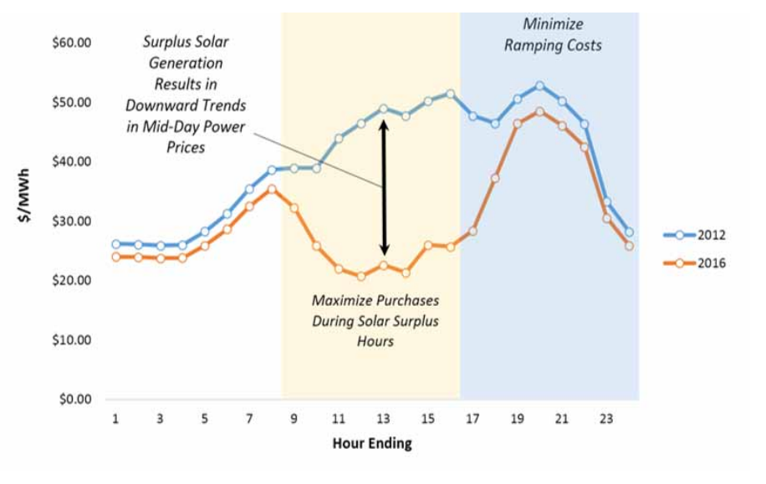

Appendix B: First Customer Survey Full Results
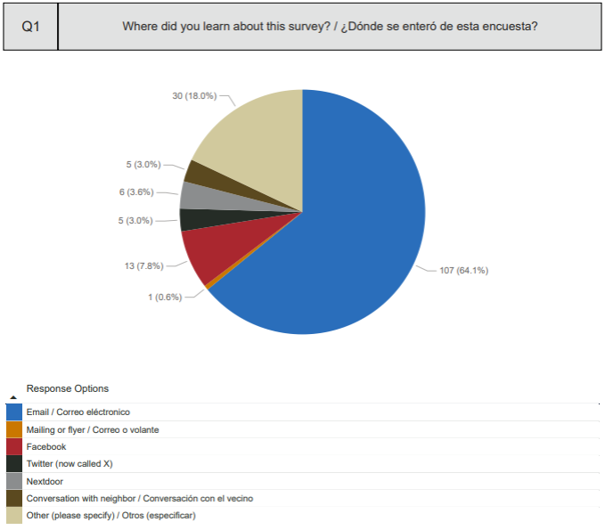
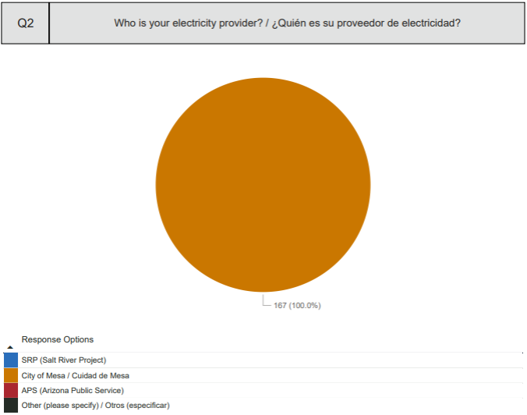
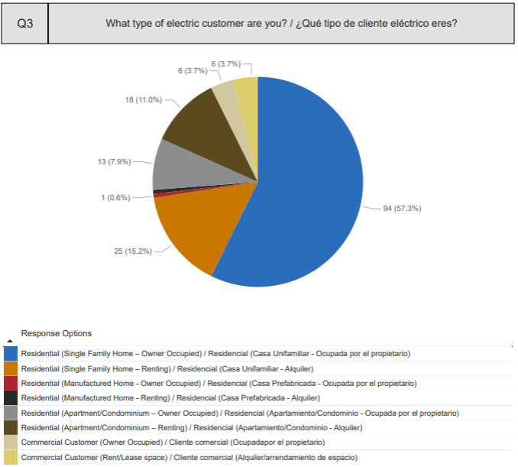
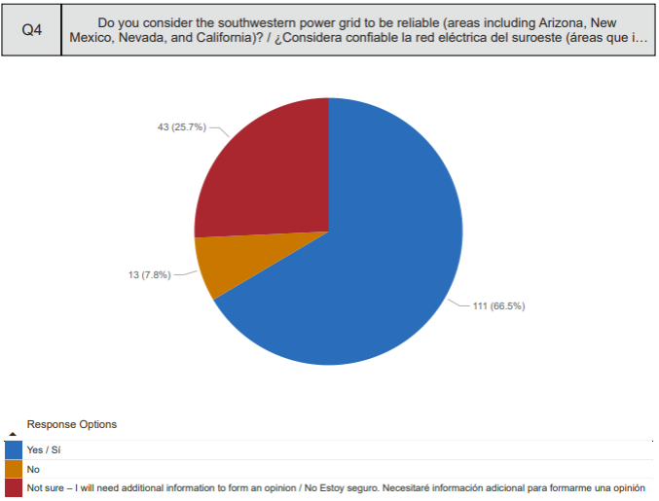
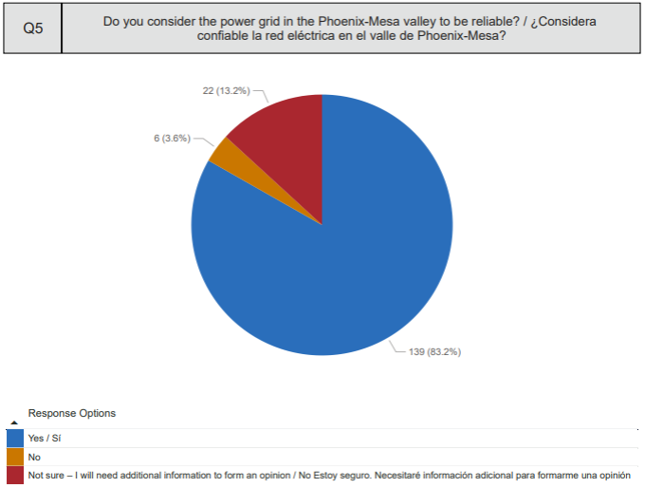
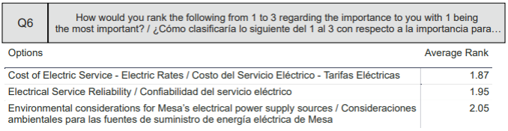
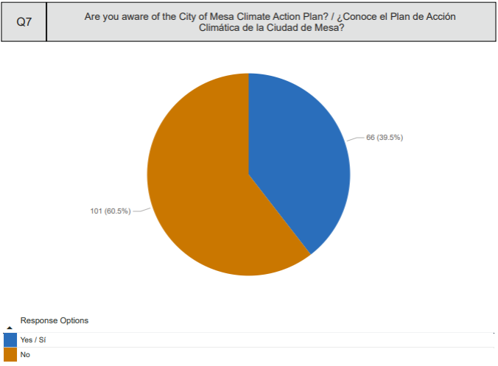
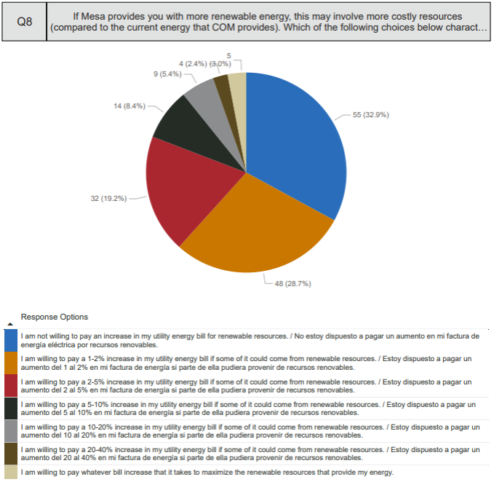
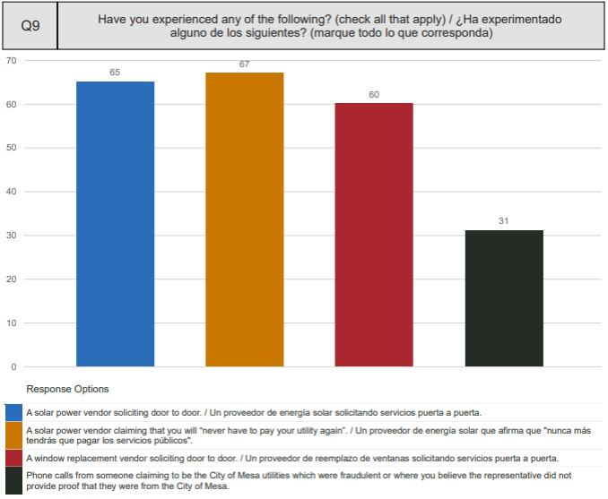
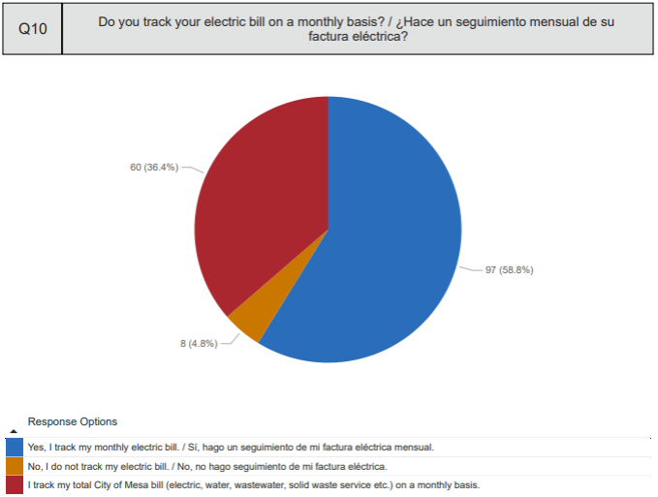
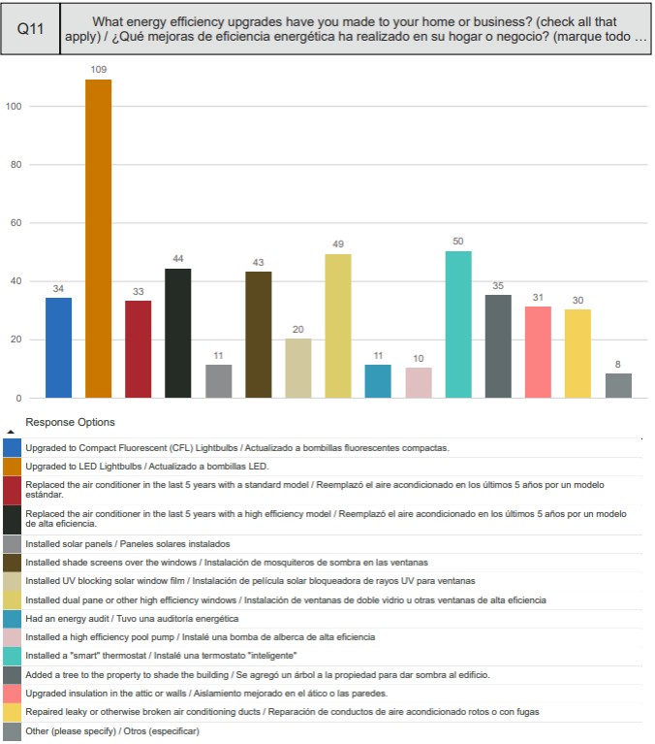
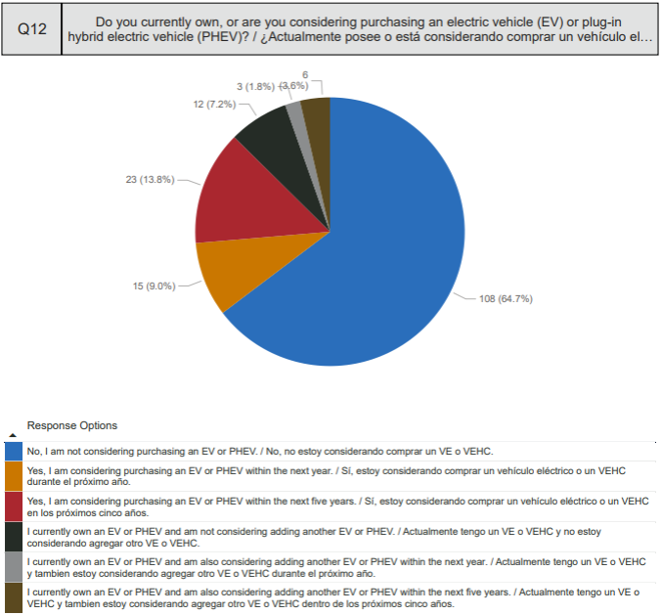
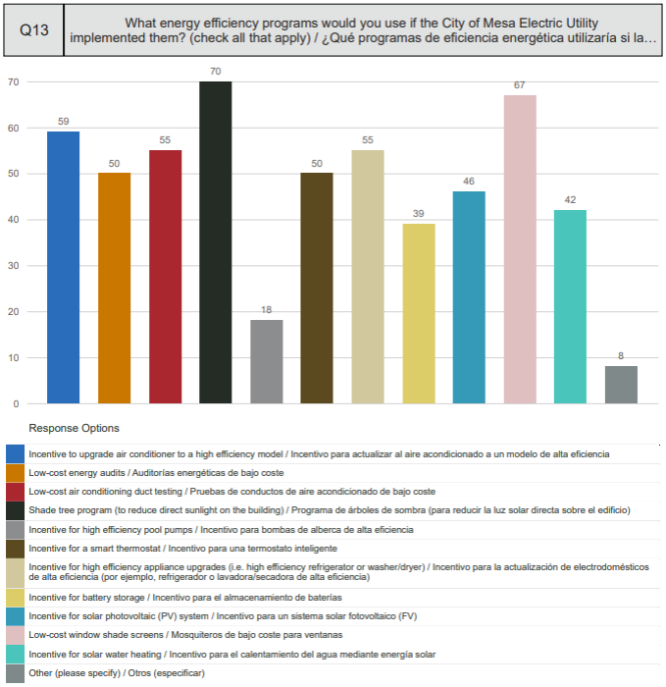

Appendix C: Western Area Power Administration IRP Requirements
1. Does the IRP evaluate the full range of alternatives for new energy resources (905.11(a))?
- New generating capacity?
- Power purchases?
- Energy conservation and efficiency?
- Cogeneration and district heating/cooling applications?
- Renewable energy resources?
2. Does the IRP provide adequate and reliable service to the customer’s electric consumers (905.11(a))?
3. Does the IRP take into account the necessary features for system operation (905.11(a))?
- Diversity?
- Reliability?
- Dispatchability?
- Other risk factors?
4. Does the IRP take into account the ability to verify energy savings achieved through energy efficiency (905.11(a))?
5. Does the IRP take into account the projected durability of such savings measured over time (905.11(a))?
6. Does the IRP treat demand and supply resources on a consistent and integrated basis (905.11(a))?
7. Does the IRP consider electrical energy resource needs? The IRP may, at the customer’s option, consider water, natural gas, and other energy resource options (905.11(b)).
8. Does the IRP identify and compare resource options? The customer must conduct an assessment and comparison of available existing and future supply and demand-side resource options based on its size, type, resource needs, geographic location and competitive situation. The options should relate to the customer’s unique resource situation as determined by profile data (service area, geographical characteristics, customer mix, historical loads, projected growth, existing system data, rates and financial information) (905.11(b)(1)).
- Supply-side options include, but are not limited to, purchased power contracts, and conventional and renewable generation options (905.11(b)(1)(i)).
- Demand-side options alter the customer’s use pattern to provide for an improved combination of energy services to the customer and ultimate consumer (905.11(b)(1)(ii)).
- Considerations that may be used to develop potential options include cost, market potential, consumer preferences, environmental impacts, demand or energy impacts, implementation issues, revenue impacts, and commercial availability (905.11(b)(1)(iii)).
9. Does the IRP clearly demonstrate that decisions were based on a reasonable analysis of the options (905.11(b)(1)(iv))?
10. Does the IRP include an action plan describing specific actions the customer will take to implement the IRP (905.11(b)(2))?
11. Does the IRP list the time period that the action plan covers (905.11(b)(2)(i))?
12. Does the IRP include an action plan summary consisting of (905.11(b)(2)(ii)(a-c):
- Actions the customer expects to take in accomplishing the goals identified in the IRP?
- Milestones to evaluate accomplishment of those actions during implementation?
- Estimated energy and capacity benefits for each action planned?
13. Does the IRP, to the extent practicable, minimize adverse environmental effects of new resource acquisitions and document these efforts (905.11(b)(3))?
14. Does the IRP include a qualitative analysis of environmental effects in a summary format (905.11(b)(3))?
15. Does the IRP provide ample opportunity for full public participation in preparing and developing the IRP (905.11(b)(4))?
16. Does the IRP include a brief description of public involvement activities (905.11(b)(4))?
- How the customer gathered information from the public?
- How public concerns were identified?
- How information was shared with the public?
- How public comments were responded to?
17. Does the IRP document that each MBA member approved the IRP, confirming that all requirements have been met (905.11(b)(4)(i))?
18. Does the IRP contain the signature of each MBA member’s responsible official, or document passage of an approval resolution by the appropriate governing body (905.11(b)(4)(i))?
19. Does the IRP contain a statement that the customer conducted load forecasting, including specific data (905.11(b)(5))?
20. Does the IRP contain a brief description of measurement strategies for identified options to determine whether the IRP’s objectives are being met (905.11(b)(6))?
21. Does the IRP identify a baseline from which the customer will measure the benefits of IRP implementation (905.11(b)(6))?
22. Does the IRP specify the responsibilities and participation levels of individual members of the MBA and the MBA (905.12(b)(2))?

https://cleantechnica.com/2024/02/14/us-ev-sales-up-385-since-2019-normal-ice-vehicle-sales-down-14/
https://www.usbr.gov/projects/index.php?id=207
https://www.usbr.gov/projects/index.php?id=47
Due to shading, suboptimal tilt, inverter clipping and other factors, Mesa views this capacity as approximately equivalent to 2.03 MW of utility solar capacity.
“Constellation” may refer to Constellation Energy Generation, LLC or Exelon Generation Company, LLC, who both trade using the same EEI as they are corporate affiliates.
Citigroup Energy, Inc.
BP Energy Company
The Cortaro-Marana Irrigation District is also a signatory to the RMS agreement, but does not actively participate in the group’s resource sharing activities.
10 CFR 905.11.(b)(4)(i) addresses this requirement. Part of WAPA's Energy Planning and Management Program of 1995 which was required by Section 114 of the EPACT of 1992
https://www.eia.gov/electricity/state/arizona/
http://www1.eere.energy.gov/buildings/appliance_standards/residential/pdfs/ac_factsheet.pdf
https://newatlas.com/energy/world-record-offshore-wind-turbine-dongfang-26-mw/#:~:text=Dongfang's%2026%2DMW%20turbine%20surpasses,148%20GW%20of%20wind%20capacity.
72% of the operating geothermal generation capacity in the United States is in California and 23% of the operating geothermal generation capacity in the United States is in Nevada.
There are two operating biomass powerplants in Arizona; a ~3 MW plant near Eagar and a ~27 MW plant west of Snowflake
This response is approximately three times the amount of input received for Mesa’s last IRP in 2019.
https://www.cbo.gov/publication/58860

