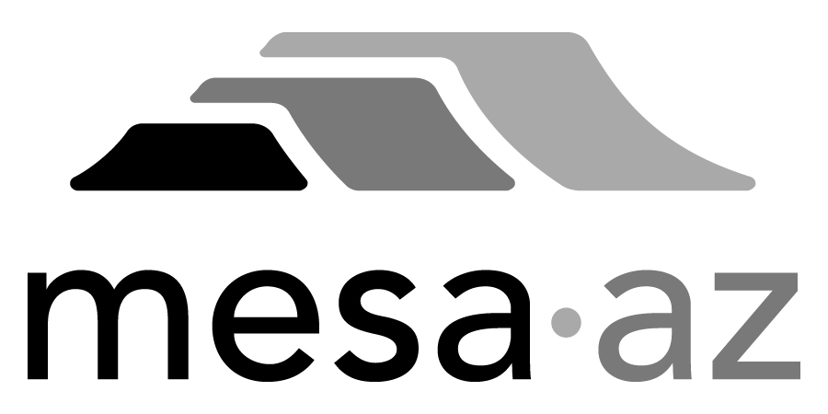 City Council Report

Date: January 27, 2025
To: City Council
Through: Michael Kennington, Deputy City Manager/Chief Financial Officer
From: Edward Quedens, Business Services Director
Kristy Garcia, Procurement Administrator
Subject: Use of a Cooperative Contract for the Purchase of One (1) Hydro Excavator (Addition) for the Fleet Services and Water Resources Departments (Citywide)

Recommendation

Council is requested to approve the award as recommended.

The Fleet Services and Water Resources Departments and Procurement Services recommend authorizing the purchase using the Sourcewell cooperative contract with Arizona Wastewater Industries, Inc. at $614,000.

Background / Discussion

The Water Resources Department is requesting a new hydro excavator needed for digging where abundant utility conflicts are present. As public right-of-way becomes more congested with underground utilities such as fiber optic and other buried lines, access to water infrastructure for maintenance or main-break repairs become more restrictive, sometimes prohibiting the use of a traditional backhoe. A hydro excavator facilitates more surgical digging to give crews access to water infrastructure while minimizing costly damage to adjacent, exposed utilities. The Water Resources Department is currently renting a hydro excavator for these purposes at a cost of $15,000 per month for 15 hours of use per week which doesn’t meet the current and projected Departmental needs.

The Sourcewell cooperative contract has been competitively bid and meets the City’s procurement requirements. Utilizing the Sourcewell contract allows the City to receive competitive rates based on a formally solicited agreement. The City believes the pricing is fair and reasonable and soliciting for this product would not result in the City receiving more favorable pricing or terms. The vendor has confirmed the Sourcewell contract offers the best cooperative pricing available.

Purchase Information

Action: Award
Procurement Type: Cooperative Contract Use
Contract Number: 2025120
Contracting Agency/Contract Number: Sourcewell/101221 - SCA
Local Consideration: Policy did not apply to this procurement method
Initial Contract Term: 1/27/2025 – 11/29/2025
Possible Renewals: None
Funding Source: WTR Utility Replacement Extension and Renewal fund
AWARD RECOMMENDATION
Quantity (1) – 2025 Freightliner 114SD RamVac HX-12 Excavator
Base Price  Sourcewell Contract Discount (3%)  Sub Total  Ram Vac Options  Freightliner Chassis  Sub Total  Phoenix Step Tax  Phoenix Sales Tax (8.3%)  Freight  Warranty  Total | $366,253.00  ($10,987.59)  $355,265.41  $44,703.42  $155,065.32  $555,034.15  $1,194.20  $44,915.30  $8,000.00  $4,530.00  $613,673.65

One (1) Addition, Vehicle Number 6126, for the Water Resources Department, funded by WTR Utility Replacement Extension and Renewal fund

