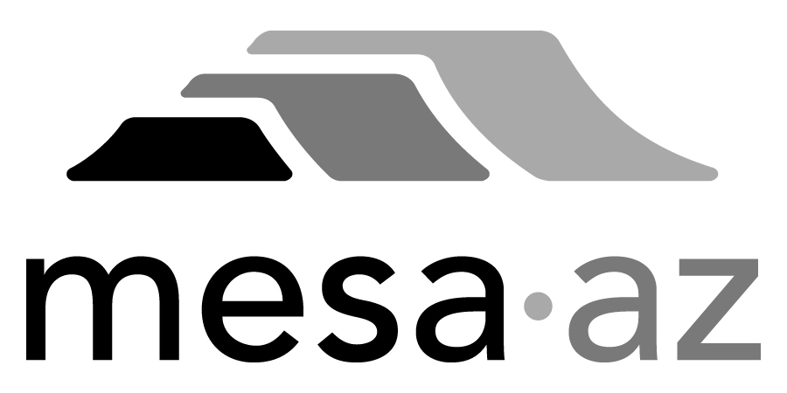 City Council Report

Date: January 27, 2025
To: City Council
Through: Michael Kennington, Deputy City Manager/Chief Financial Officer
From: Edward Quedens, Business Services Director
Kristy Garcia, Procurement Administrator
Subject: Use of a Cooperative Contract for the Purchase of Two (2) Compact Loaders and One (1) Backhoe Loader (Replacements) for the Fleet Services, Transportation, and Parks, Recreation and Community Facilities Departments (Citywide)

Recommendation

Council is requested to approve the award as recommended.

The Fleet Services, Transportation, and Parks, Recreation and Community Facilities Departments, and Procurement Services recommend authorizing the purchase using the State of Arizona cooperative contract with Empire Southwest, LLC. dba Empire Machinery (a Mesa business) at $493,937, based on estimated requirements.

Background / Discussion

The Fleet Services, Transportation, and Parks, Recreation, and Community Facilities Departments are requesting the purchase of compact loaders and backhoe loaders to replace older equipment that has reached the end of its useful life. The Transportation Department’s Right of Way Group needs a compact loader to maintain the City’s open channel drainage system. The Parks, Recreation and Community Facilities Department uses compact loaders and backhoe loaders to support various maintenance and repair-related activities in the parks, basins, cemetery, stadium, aquatic facilities, sports facilities, and recreation centers.

The State of Arizona cooperative contract has been competitively bid and meets the City’s procurement requirements. Utilizing the state contract allows the City to receive competitive rates based on a formally solicited agreement. The City believes the pricing is fair and reasonable and soliciting for these products would not result in the City receiving more favorable pricing or terms. The local dealer has confirmed the State of Arizona contract offers the best cooperative pricing available locally.

Purchase Information

Action: Award
Procurement Type: Cooperative Contract Use
Contract Number: 2025098
Contracting Agency/Contract Number: State of Arizona/CTR052847
Local Consideration: Policy did not apply to this procurement method
Initial Contract Term: 1/27/2025 – 12/3/2025
Possible Renewals: None
Funding Source: Fleet Services operating budget through the Parks, Recreation, & Community Facilities Vehicle Replacement Fund & Transportation Department Local Street Sales Tax

AWARD RECOMMENDATION
Quantity (1) – 2024 Caterpillar 299D3 XPS Compact Loader
Base Price  Options  State of Arizona Contract Discount (21%)  Sub Total  Pre-Delivery Inspection  City Tax (8.3%)  Total | $131,740.00  $61,889.00  ($40,662.09)  $152,966.91  $2,130.00  $12,873.04  $167,969.95
One (1) Replacement for Vehicle #1983, for Transportation Department, funded by Local Street Sales Tax

AWARD RECOMMENDATION
Quantity (1) – 2024 Caterpillar 265 XPS Compact Loader
Base Price  Options  State of Arizona Contract Discount (21%)  Sub Total  City Tax (8.3%)  Total | $103,670.00  $75,766.00  ($37,681.56)  $141,754.44  $11,765.62  $153,520.06
One (1) Replacement for Vehicle #0076, for the Parks, Recreation, and Community Facilities Department, funded by the Vehicle Replacement Fund

AWARD RECOMMENDATION
Quantity (1) – 2024 Caterpillar 420XE Backhoe Loader
Base Price  Options  State of Arizona Contract Discount (22%)  Sub Total  City Tax (8.3%)  Total | $119,420.00  $84,721.00  ($44,911.02)  $159,229.98  $13,216.09  $172,446.07
One (1) Replacement for Vehicle #111, for Parks, Recreation and Community Facilities Department, funded by the Vehicle Replacement Fund

