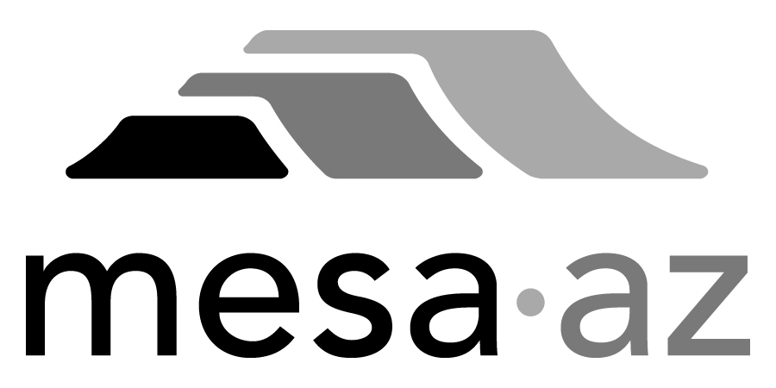 City Council Report

Date: January 27, 2025
To: City Council
Through: Michael Kennington, Deputy City Manager/Chief Financial Officer
From: Edward Quedens, Business Services Director
Kristy Garcia, Procurement Administrator
Subject: Three-Year Term Contract with Two-Year Renewal Options for Custodial Services – Zones 5, 6, and 7 for the Facilities Management Department (Citywide)

Recommendation

Council is requested to approve the award as recommended.

A committee representing Facilities Management and Procurement Services evaluated responses. The evaluation committee recommends awarding the contract to the highest-scored proposal from Landmark Building Maintenance Services, LLC. dba Pivot Building Services for Custodial Services – Zone 5 at $1,353,000 annually, Zone 6 at $1,538,000.00 annually; and Zone 7 at $848,000 annually, for a total of $3,739,000 annually, with an annual increase allowance of up to 5% or the adjusted Consumer Price Index. The initial term of the contract is 5/1/2025 – 4/30/2028.

Background / Discussion

This contract provides custodial services such as cleaning offices, restrooms, and common areas; waste management; restocking supplies; and providing specialized cleaning services for approximately 68 City facilities. This contract will ensure consistent upkeep, compliance with health and safety standards, and enhance the usability and aesthetics of City-owned properties.

City staff issued three Request for Proposals (RFP’s) (one for each of three zones designated as Zones 5, 6, and 7) to all registered Custodial Service providers. The City received proposals for all three Zones. Janitorial Today, LLC. did not submit all the required documents and responded to the wrong solicitation for Zone 5. Civic Nexus Partners, LLC. did not provide any pricing, qualifications, or solution information for Zone 6. Both vendors were deemed non-responsive. The remaining proposals were evaluated and scored in accordance with the City’s established policies and procedures and relative to the scoring criteria in the solicitation. Based on the evaluation results, the committee recommends awarding the contract to the highest-scoring respondent of each Zone.

Purchase Information

Action: Award
Procurement Type: Request for Proposals
Contract Number: 2025058 – Zone 5; 2025059 – Zone 6; and 2025060 – Zone 7
Local Consideration: Policy did not apply to this procurement method
Protests Received: None
Initial Contract Term: Three (3) years: 5/1/2025 - 4/30/2028
Possible Renewals: Up to a maximum of two (2) years subject to Administrative review and approval
Funding Source: Facilities Maintenance operating budget

Proposal Responses

A3D Services, LLC. – Laveen, AZ
BIO-Janitorial Service, Inc. – Glendale, AZ
CCS Facilities Services – Arizona, Inc. (PBC Phoenix, Inc.) – Denver, CO
The DM Caldwell Corporation – Tucson, AZ (only submitted for Zones 5 & 6)
Historic Palm, LLC. dba Oranje Commercial Janitorial – Phoenix, AZ
Kellermeyer Bergensons Services, LLC. (KBS) – Oceanside, CA
Kleen-Tech Services, LLC. dba Sonoran, a Kleen Tech Company – Phoenix, AZ
Landmark Building Maintenance Services, LLC. dba Pivot Building Services – Tempe, AZ
The Loft Group, LLC. – Pearl City, HI
Office Keepers, LLC. – Mesa, AZ
Slate USA, Inc. – New York, NY
Titian Cleaning, LLC. dba OMEX International – Tempe, AZ
UBM Enterprise, Inc. – Dallas, TX
Universal Building Maintenance dba Allied Universal Janitorial Services – Tempe, AZ
United Maintenance Company, Inc. – Chicago, IL (only submitted for Zones 5 & 6)
Verde Clean – Phoenix, AZ
Villa 13, LLC. dba Trooper USA, LLC. – Mesa, AZ

Non-Responsive Proposals

Janitorial Today, LLC. – Did not submit all required documents and responded to the wrong solicitation (Zone 5)
Civic Nexus Partners, LLC. – Did not provide any pricing, qualifications, or solution information (Zone 6)

Final Scoring (Zone 5)

Respondent | Total Points Possible / 550
A3D Services, LLC. | 233.07
BIO-Janitorial Service, LLC. | 366.98
The DM Caldwell Corporation | 265.22
Historic Palm, LLC. | 359.36
Kellermeyer Bergensons Services, LLC. | 413.64
Kleen-Tech Services, LLC. | 423.02
Landmark Building Maintenance Services, LLC. (Recommended) | 451.21
The Loft Group, LLC. | 166.79
Office Keepers, LLC. | 309.97
PBC Phoenix, Inc. | 429.55
Slate USA, Inc. | 239.35
Titian Cleaning, LLC. | 376.02
UBM Enterprise, Inc. | 386.84
United Maintenance Company, Inc. | 319.52
Universal Building Maintenance | 380.50
Verde Clean | 380.48
Villa 13, LLC. | 366.17

Final Scoring (Zone 6)

Respondent | Total Points Possible / 550
A3D Services, LLC. | 235.13
BIO-Janitorial Service, LLC. | 366.72
The DM Caldwell Corporation | 269.28
Historic Palm, LLC. | 367.01
Kellermeyer Bergensons Services, LLC. | 415.21
Kleen-Tech Services, LLC. | 424.92
Landmark Building Maintenance Services, LLC. (Recommended) | 460.39
The Loft Group, LLC. | 165.85
Office Keepers, LLC. | 319.35
PBC Phoenix, Inc. | 435.60
Slate USA, Inc. | 238.85
Titian Cleaning, LLC. | 376.33
UBM Enterprise, Inc. | 396.88
United Maintenance Company, Inc. | 325.06
Universal Building Maintenance | 380.50
Verde Clean | 382.22
Villa 13, LLC. | 375.83

Final Scoring (Zone 7)

Respondent | Total Points Possible / 550
A3D Services, LLC. | 230.84
BIO-Janitorial Service, LLC. | 335.40
Historic Palm, LLC. | 361.05
Kellermeyer Bergensons Services, LLC. | 408.03
Kleen-Tech Services, LLC. | 418.16
Landmark Building Maintenance Services, LLC. (Recommended) | 451.86
The Loft Group, LLC. | 166.77
Office Keepers, LLC. | 313.08
PBC Phoenix, Inc. | 429.63
Slate USA, Inc. | 237.80
Titian Cleaning, LLC. | 371.74
UBM Enterprise, Inc. | 388.25
Universal Building Maintenance | 380.50
Verde Clean | 378.38
Villa 13, LLC. | 366.21

