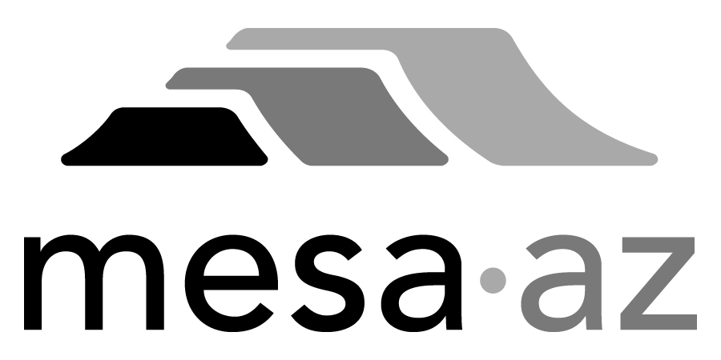 City Council Report

Date: January 27, 2025
To: City Council
Through: Michael Kennington, Deputy City Manager/Chief Financial Officer
From: Edward Quedens, Business Services Director
Kristy Garcia, Procurement Administrator
Subject: Use of a Cooperative Contract for the Purchase of One (1) Massey Ferguson Tractor (Replacement) for the Fleet Services Department and Falcon Field (Citywide)

Recommendation

Council is requested to approve the award as recommended.

The Fleet Services Department, Falcon Field, and Procurement Services recommend authorizing the purchase using the Omnia Partners cooperative contract with Empire Cat (a Mesa business) at $129,000 based on estimated requirements.

Background / Discussion

The Fleet Services Department and Falcon Field are requesting the purchase of one (1) Massey Ferguson Tractor to replace a piece of older equipment that has reached the end of its useful life. This tractor will be used to perform numerous airfield maintenance activities. The primary purpose of this equipment will be to mow infield areas, keeping them free from vegetative growth to ensure compliance with Federal Aviation Administration specifications. Additionally, the tractor transports bulk materials on pallets, grades unpaved surfaces, and tows equipment such as turbine blowers to keep paved surfaces free from foreign object debris.

The Omnia Partners cooperative contract has been competitively bid and meets the City’s procurement requirements. Utilizing the Omnia Partners contract allows the City to receive competitive rates based on a formally solicited agreement. The City believes the pricing is fair and reasonable and soliciting for this product would not result in the City receiving more favorable pricing or terms.

Purchase Information

Action: Award
Procurement Type: Cooperative Contract Use
Contract Number: 2025113
Contracting Agency/Contract Number: Omnia Partners/212816
Local Consideration: Policy did not apply to this procurement method
Initial Contract Term: 1/27/2025 – 10/2/2026
Possible Renewals: None
Funding Source: Falcon Field CIP funds through the Airport Enterprise Fund

AWARD RECOMMENDATION
Quantity (1) – 2024 Massey Ferguson MF4710 Tractor
List Price  Omnia Partners Contract Discounts (% based on manufacturers)  Sub Total  Vehicle Preparation  Freight  Delivery  Warranty  Sub Total  Mesa Sales City Tax (8.3%)  Total | $137,146.00  ($33,097.12)  $104,048.88  $3,325.00  $6,504.00  $500.00  $4,940.00  $119,317.88  $9,175.89  $128,493.77

One (1) Replacement for Vehicle #965 for Falcon Field, funded by the Airport Enterprise Fund

