 City Council Report

Date: January 13, 2025
To: City Council
Through: Marc Heirshberg, Deputy City Manager

From: Scott Bouchie, Energy Resources & Sustainability Director
Anthony Cadorin, Energy Resources Program Manager
Giao Tran, Energy Resources Coordinator

Subject: Approval of a Resolution authorizing the acquisition of interstate natural gas pipeline transmission capacity through participation in the pipeline bidding process, and approving entry of associated contracts upon successful bid.

Purpose and Recommendation

The City of Mesa Energy Resources Department recommends that the City Council authorize the City Manager or his designee to acquire additional firm transportation service with interstate natural gas pipeline companies through participation in the bidding process for a term up to 50 years, and approving entry of associated contracts upon successful bid.

Background

City of Mesa (Mesa) operates a natural gas utility that provides service to two major service areas: 1) the Mesa System which is approximately 90-square miles primarily within City limits, and 2) the Magma System which is approximately 236-square miles located southeast of the City in Pinal County. Mesa’s combined natural gas system is comprised of 1,521 miles of distribution mains and serves 44,128 customers on the Mesa System and 33,110 customers on the Magma System. Both the Mesa System and the Magma System have experienced rapid growth over the past decade creating an increasing need for natural gas supplies and the transportation of those supplies to Mesa’s city gate stations.
Kinder Morgan’s El Paso Natural Gas interstate transmission system (EPNG) delivers natural gas from two areas of the southwest, the Permian Basin and the San Juan Basin. The gas from the San Juan Basin and Permian Basin is transported to Arizona through EPNG’s north mainline and south mainline system, respectively.

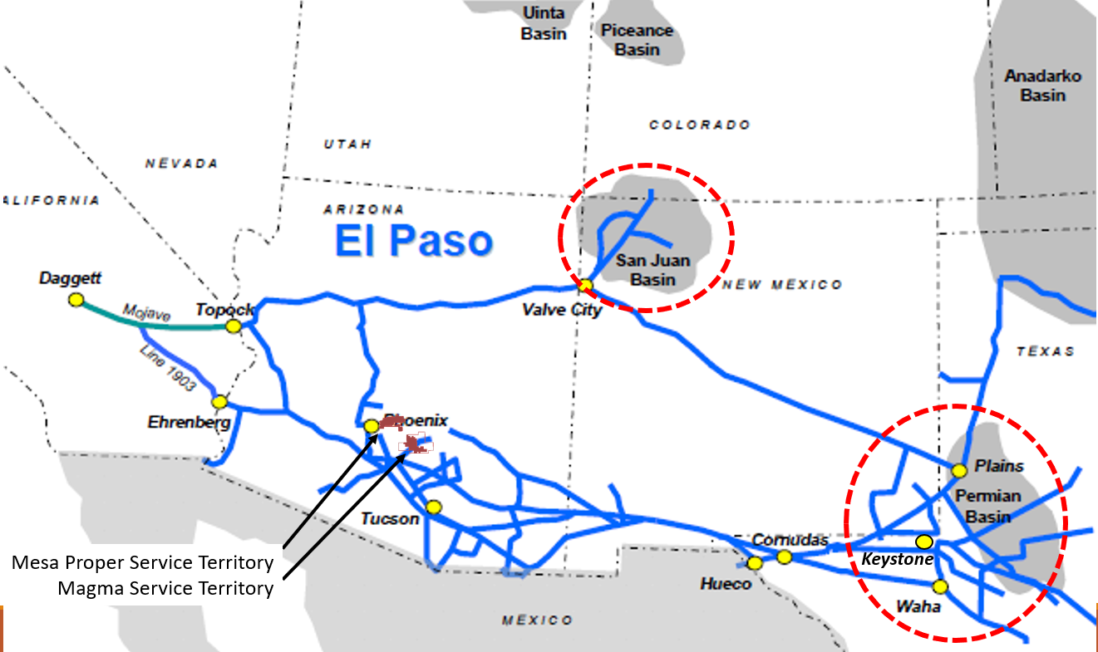
Figure 1) The El Paso Natural Gas transmission system

From the mainline system, natural gas must then be transported on a series of smaller lateral pipelines into the Phoenix area where Mesa’s city gate stations then can accept the natural gas.
Mesa’s transportation contracts with EPNG attempt to reserve enough pipeline capacity on EPNG’s pipeline (measured in Dekatherm per day or Dth/day) to ensure that Mesa can transport enough gas to cover design day weather events with a low likelihood of penalties. As Mesa’s system has grown, more capacity is needed to continue avoiding penalties.
Mesa can acquire additional pipeline capacity (or achieve similar results) through various methods, which include:
- Bidding on expiring contracts for pipeline capacity.
- Requesting and/or bidding on a new contract on the existing, currently available pipeline capacity.
- Requesting a new contract through system expansion.
- Participating in, or constructing, a natural gas storage facility.
- Generating renewable natural gas that is supplied directly onto our system to offset the need for additional pipeline capacity.

On December 17, 2024, EPNG posted capacity on their system that is open for bidding and would provide small quantity of additional pipeline capacity for Mesa’s current and future load growth in the months of August through May. The bids for this capacity must be received by EPNG by January 16th, 2025 at 2:00 PM MT. Since this is a contract for existing pipeline capacity within EPNG’s system, Mesa is not expected to bid and pay higher than the current maximum tariff rate.
Table 1 illustrates the pipeline capacity available in the open season and Mesa’s expected monthly expense that would be paid if Mesa acquired it:

Table 1) EPNG's available capacity in Dth/day and expected monthly expense.

 | Transportation Capacity  (Dth/day) | Monthly Payment at current rate ($)
Jan | 406 | $ 3,623.27
Feb | 305 | $ 2,721.91
Mar | 427 | $ 3,810.68
Apr | 628 | $ 5,604.46
May | 2,261 | $ 20,177.84
June | 0 | $ -
July | 0 | $ -
Aug | 400 | $ 3,569.72
Sep | 375 | $ 3,346.61
Oct | 351 | $ 3,132.43
Nov | 331 | $ 2,953.94
Dec | 340 | $ 3,034.26

Additionally, this new capacity will complement the capacity gained through Mesa’s current Clausen Gate Station project.

Discussion

EPNG evaluates bids for pipeline capacity based on a strict present value calculation of the value of each bid. Because EPNG has a maximum tariff rate for its existing pipeline capacity set by the Federal Energy Regulatory Commission, it cannot evaluate bids above this maximum tariff rate. Because the bids are all evaluated at the maximum tariff rate for the particular capacity under consideration, the present value calculation to determine the winning bidder comes down to the length of the bid provided. Over the past decade, bids have been steadily increasing in length to where winning bids above 30 years are most common. As a result, if Mesa expects to win this capacity, a very long bid, exceeding 30 years, perhaps up to 50 years, will be required. Through a Right of First Refusal (ROFR) open season in 2022, a South mainline contract was completed with EPNG for 144 years.
Because the opportunity to bid on expiring contracts or newly available capacity is often on short notice and infrequent, the Energy Resources Department is asking for authority to bid in fiscal year 2024/2025 and also for authority to make similar bids during the upcoming fiscal year 2025/2026.

Alternatives

Mesa could choose not to bid for the EPNG pipeline capacity currently posted and due on January 16th and look for another expiring contract or opportunities in the future. However, expiring contracts and capacity that meet the required paths on the EPNG’s system to delivery gas specifically to Mesa’s distribution system are rare in occurrence and at times can be of a quantity or shape that is not suitable to Mesa’s growth needs.

Fiscal Impact

The costs of any resulting natural gas transportation capacity will generally be recovered though the purchased natural gas cost adjustment factor (PNGCAF) and are adjusted as frequently as monthly as costs increase or decrease throughout the year.

Coordinated With

Any subsequent negotiations of a contract as a result of this authorization will be coordinated with the City Attorney’s Office.

) As of Mesa’s last annual report, issued March 2024
) Active Customer Information System billing customer accounts as of August 2024
Various forms of storage are used throughout the industry, however, storage is not common (yet) on the west coast due to the abundance of supply and the capital cost involved. Mesa remains committed to searching for any such opportunities though, should an economical, reliable opportunity arise.
This capacity on existing pipeline came from EPNG’s system modification via line 1110 expansion.
If Mesa purchases pipeline capacity directly from another pipeline capacity holder, that purchase can be at any rate negotiated between the two parties, but if the existing pipeline capacity is posted on EPNG’s bulletin board for bidding, the bid cannot exceed the maximum tariff rate.

