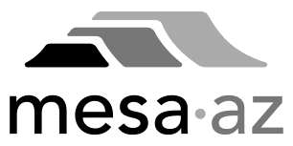
City Council Report

Date: January 13, 2025
To: City Council
Through: Michael Kennington, Deputy City Manager/Chief Financial Officer
Marc Heirshberg, Deputy City Manager
From: Brian A. Ritschel, Management and Budget Director
Scott Bouchie, Energy Resources Director
Subject: Re-adoption of Ordinance for Natural Gas Utility Rate Adjustments

This Ordinance for adjustments to the Natural Gas Utility rates is being re-adopted due to a couple typographical errors found in Ordinance No. 5898. Ordinance No. 5898, adopted on December 2, 2024, included adjustments to the Natural Gas Utility rates as made public record by Resolution No. 12298 adopted on November 18, 2024.
The re-adoption of the Ordinance for Natural Gas Utility rates only corrects the minor typographical errors and does not amend or alter any recommended rate adjustments that were considered at the November 18, 2024 or December 2, 2024 City Council meetings.
The Natural Gas Utility rate adjustments will be effective March 1, 2025.

