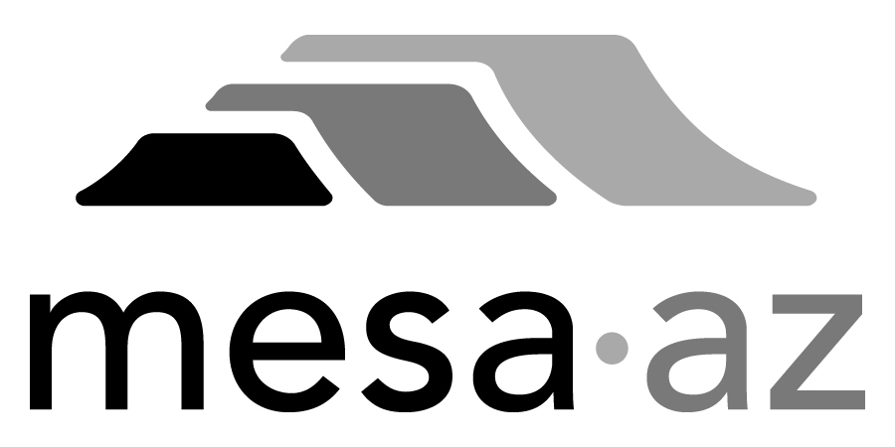 City Council Report

Date: January 27, 2025
To: City Council
Through: Michael Kennington, Deputy City Manager/Chief Financial Officer
From: Edward Quedens, Business Services Director
Kristy Garcia, Procurement Administrator
Subject: Three-Year Term Contract with Two-Year Renewal Options for Herbicide Application and Vegetation Removal Services for the Transportation Department (Funded by Local Streets Fund) (Citywide)

Recommendation

Council is requested to approve the award as recommended.

The Transportation Department and Procurement Services recommend awarding the contract to the lowest, responsive, and responsible bidder, URW, LLC. dba United Right of Way at $607,000, annually with an annual increase allowance of up to 5% or the adjusted Consumer Price Index.

Background / Discussion

The Transportation Department has a need for on-call and/or scheduled general landscape maintenance services to protect City of Mesa property and to ensure public safety. Services include pre and post herbicide applications and vegetation removal on unimproved right of ways, drainage easements, retention basins, and various associated areas throughout the City of Mesa. Transportation’s Right of Way and Storm Drain Maintenance work groups will be using this contract.

Purchase Information

Action: Award
Procurement Type: Request for Bids
Contract Number: 2025069
Local Consideration: Not applicable as there were no Mesa responses
Protests Received: None
Initial Contract Term: Three (3) years
Possible Renewals: Up to a maximum of two (2) years subject to Administrative review and approval
Funding Source: Transportation Department operating budget through Local Street Sales Tax

Bid Responses

Group A and B Total Bid

Reyes & Sons Landscaping, LLC. $399,690.35
Phoenix, AZ

Total Maintenance Erosion Control, LLC. $6,737,052.12
Phoenix, AZ

URW, LLC. dba United Right of Way $249,169.11 (Recommended)*
Phoenix, AZ *Award amount based on historical usage

