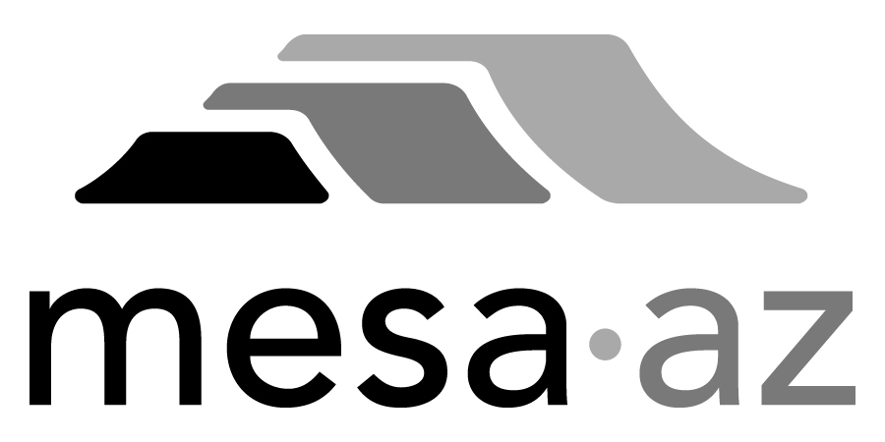 City Council Report

Date: January 27, 2025
To: City Council
Through: Michael Kennington, Deputy City Manager/Chief Financial Officer
From: Edward Quedens, Business Services Director
Kristy Garcia, Procurement Administrator
Subject: Two-Month Extension and Dollar Limit Increase to the Term Contracts for Custodial Services – Zones 5, 6, and 7 for the Facilities Management Department (Citywide)

Recommendation

Council is requested to approve the contract amendment as recommended.

The Facilities Management Department and Procurement Services recommend extending the contracts through April 30, 2025 and increasing the dollar limit with Varsity Contractors, Inc. dba Varsity Facilities Services, a KBS Company, by $522,756.47 from $3,713,335.53 to $4,236,092.00 for the remaining term of the contract.

Background / Discussion

This service contract is essential in providing custodial services to City facilities. In 2020, the City moved from a single Citywide contract to three (3) separate contracts. The City has re-solicited and the new contracts are on the Council agenda for award. This extension and increase is needed to provide uninterrupted service during the transition to a new vendor, which includes staffing, scheduling, equipping, stocking, and background checks/badging. The extension will continue at the current pricing.

Purchase Information

Action: Amendment
Procurement Type: Request for Proposals
Contract Number: Zone 5 – 2020088, Zone 6 – 2020089, and Zone 7 - 2020040
Initial Contract Term: Three (3) years
Possible Renewals: None
Funding Source: Facilities Maintenance Department operating budget

Dollar Limit History (Zone 5) 2020088
Renewal Amount (Years 4 & 5) – 2/27/2023: $1,239,250.00
Administrative Increase – 11/6/2023: $47,359.69
New Contract Amount (Years 4 & 5): $1,286,609.69
Administrative Increase – 2/28/2024: $37,157.02
New Contract Amount (Year 5): $1,323,766.71
Council Approved Increase – 5/6/2024: $33,010.74
New Contract Amount (Year 5): $1,356,777.45
Administrative Increase – 10/1/2024: $23,846.23
New Contract Amount (Year 5): $1,380,623.68
This increase request: $177,971.82
New Contract Amount (Year 5 through 4/30/2025): $1,558,595.50

Dollar Limit History (Zone 6) 2020089
Renewal Amount (Years 4 & 5) – 2/27/2023: $1,346,700.00
Administrative Increase – 2/28/2024: $38,956.28
New Contract Amount (Years 4 & 5): $1,385,656.28
Administrative Increase – 4/4/2024 $33,715.44
New Contract Amount (Years 4 & 5): $1,419,371.72
Council Approved Increase – 8/19/2024: $77,968.89
New Contract Amount (Year 5): $1,497,340.61
This increase request: $220,669.93
New Contract Amount (Year 5 through 4/30/2025): $1,718,010.54

Dollar Limit History (Zone 7) 2020040
Renewal Amount (Years 4 & 5) – 2/27/2023: $794,900.00
Administrative Increase – 3/1/2024 $21,702.29
New Contract Amount (Year 5) $816,602.29
Administrative Increase – 11/26/2024: $7,530.12
New Contract Amount (Year 5): $824,132.41
Administrative Increase – 12/18/2024: $11,238.83
New Contract Amount (Year 5) $835,371.24
This increase request: $124,114.72
New Contract Amount (Year 5 through 4/30/2025): $959,485.96

