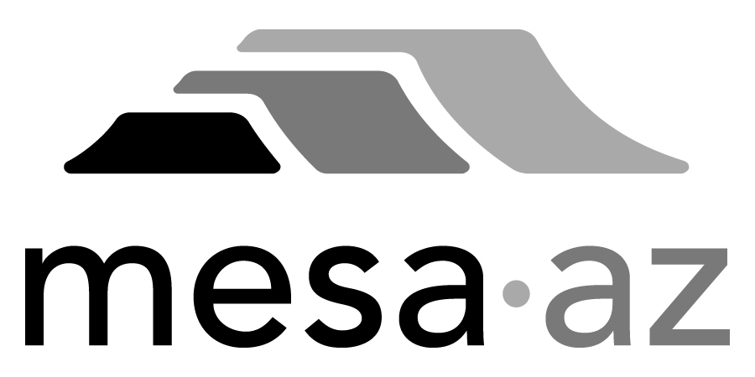 City Council Report

Date: January 27, 2025
To: City Council
Through: Michael Kennington, Deputy City Manager/Chief Financial Officer
From: Edward Quedens, Business Services Director
Kristy Garcia, Procurement Administrator
Subject: Three-Year Term Contract with Two-Year Renewal Options for Street Sweeping Services for the Transportation Department (Funded by Local Street Sales Tax) (Citywide)

Recommendation

Council is requested to approve the award as recommended.

A committee representing the Transportation Department and Procurement Services evaluated responses. The evaluation committee recommends awarding the contract to the highest-scored proposal from Precision Sweeping Services, LLC. at $767,000 annually, with an annual increase allowance of up to 5% or the adjusted Consumer Price Index.

Background / Discussion

This contract will provide street sweeping services to include routinely scheduled street sweeping, special event sweeping, and emergency response call-outs due to debris in the roadways and petroleum product spills.

City staff issued a Request for Proposal (RFP) to all registered Street Sweeping Service providers. Three (3) proposal responses were received. All proposals met the minimum qualifications and were invited to a Reverse Auction event to submit their pricing. Following the Reverse Auction event, all proposals were evaluated and scored in accordance with the City’s established policies and procedures and relative to the scoring criteria in the solicitation. Based on the evaluation results, the committee recommends awarding the contract to the highest-scoring respondent.

Purchase Information

Action: Award
Procurement Type: Request for Proposals
Contract Number: 2025040
Local Consideration: Policy did not apply to this procurement method
Protests Received: None
Initial Contract Term: Three (3) years
Possible Renewals: Up to a maximum of two (2) years subject to Administrative review and approval
Funding Source: Transportation operating budget through Local Street Sales Tax

Proposal Responses

Offsite Sweeping, LLC. – Phoenix, AZ
Precision Sweeping Services, LLC. – Phoenix, AZ (Recommended)
SCA of CA, LLC. – Seven Hills, OH

Final Proposal Scoring Results

Respondent | Total Points Possible / 1,000
Offsite Sweeping, LLC. | 823.00
Precision Sweeping Services, LLC. (Recommended) | 945.00
SCA of CA, LLC. | 868.00

